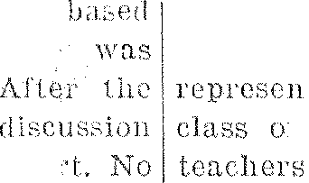

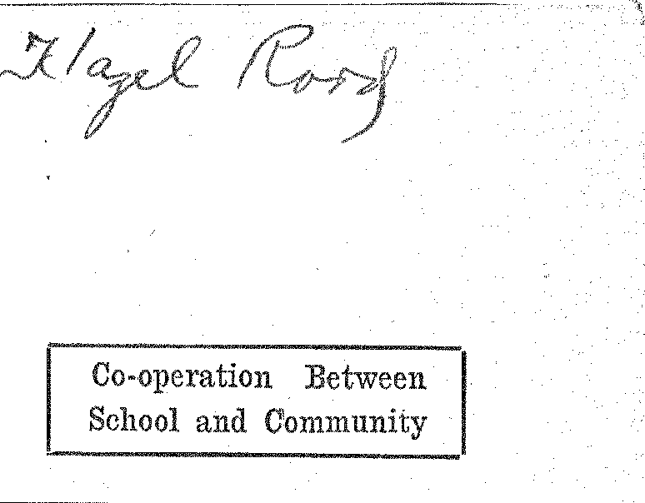

Co-operation Between
  
School and Community

|  |  |  |  |  |
| --- | --- | --- | --- | --- |
|  |  |  |  |  |
| Higher Scholarship;  Better izenship |  |
|  |  |
|  |  |  |  |

|  |  |  |  |  |  |
| --- | --- | --- | --- | --- | --- |
| VOLUME VI | |  | 0 ( | .1•11,1- | NUMBER 2 |
|  |  |  |  |  |  |

HOME ECONOMICS DEPARTMENT }EPHEARS FINE

'DRESS BY MISS FINLAYSON, STALL-, CTOR

° TEACHERS' INSTITUTE

HELD OCTOBER 5-10

County Superintendent and Other
  
Good Speakers Address Yearly
  
Gathering of Teachers.

All rural and consolidated school teachers of Griggs county were in attendance at the annual institute licld at the gymnasium from October G to 10. The teachers speak highly of he quality work presented and feel that they received many splen­did ideas for their year of work.

Business Men Entertain

At a special welcome the Business Men's Club entertained the teachers durrs at a "get-together" party on Monday evening. Monroe nocmicsIrr Mr. Rogers had charge or the entertainment. The Home Ec­ono nicmics Club served refreshments,

Good Instructors

]Miss Beatrice Johnstone of Grand Forks and Mrs. Simenson of Vallproblem were the instructors for thteachershey know country school problen and the difficulties t

the teaellers in schools must

raodsrefore, they were able
  
give the teachers helpful ideas and methliods.

In addition to 1,-

tars, Couny Sup(' n endrott I atl lda
  
Johnson mitt . .t,t,t1, the

Work.

Visit City Schools

While here the advantageachers were invited to visit the city schools. Many took advarttatge of the oppor­tunity, and attended classes in which they Were particularly interested.

Beneficial Results

This was one of the best institutes ever held in Griggs county. and the teachers returned to their respective schools feeling that the week had. been most beneficial to them,

DEBATE QUESTION FOR H. S. LEAGUE CHOSEN

"Resolved, That the Trend front local to Federal 'Control Which Has Characterized Our Government Dur lug Recent Years, is Inimical to t AVelfare of the United States."

is the question which the Rare.' Public Information of rite University Extension Division, Gland Forks,
  
has determined shall b, the subject et controversy in the High School Debating League of North Dakota. for 1926.

In order to avoid mos, :less ("hems, sloe the praseology of the question;

debating teams shoo accept these

cis: Local control • meant to 'nclude that wielded by city, town­_ j , county, district ... state. The

tr, "federal" means the control of the ]Tutted States government through Congress, th • Fres Men t, the decision of the Sepretne Court and by various boards and commis­sions of the federal *government.* at Washington, According to the Bu­reau, the expression "during recent years" refers, to the period of time beginning some fifteen or twenty years ago, including Ile present.

Application for entering the 192G debate contest must be made before the 16th of December. This is earlier than last year. The change is made in order to pair the teams and to notify them before the Christ-

Continued 011 Page Three

GIWS' IVELFP

FREPARAL _

Miss Irene Pia: Selected to Direct
  
Destinies of Society for Com-
  
ing School. Year.

171trite years ago, Ivlien the Cla

of '26 were Freshmen, a society girls was organized in high school and called the Girls' V,Telfare

society of this na.tu.e was d

able for protnoiing co-operati,m art

good feeling among Die

Women s Senate, a hoard

members and one faculty me had up to this time attempted t, these things. r.l'he board, with
  
assistance of some Avonwri •of

community, hail made a sot of rules which every girl had to follows Any­one who violated these rules was brought before the Senate .111(ri they decided to punish or not to punish the girl. The fount of 'minis

varied with the offense. The objec­tion Avhich the girls raised to this board was that it was too diet atory,

so they would rather

other 1:(11111 of union.

As a consequence, Girls' Wel-

fare, Society was ois.

ed to lead and not to die.ate,

society met every Friday. The

first part of meeting was
  
to business and a program around some problent which

suggested by the girls. program there was open

in which all the girls took pa.

rules were made by the soc garding conduct. Each girl

rule her actions by the dHs

in the meetings,

During the year the society 1••••1-

INS PROGRAM IN

:IbAL ACTIVITIES

to plut on a public. program In
  
middle le year and a get-
  
iher h ai ty soar the first part of

to

two years the plan was put a,ero. s with great. success aunt the regular meetings were very spir­ited affairs. Last year, however, they failed to get their public pro­gram in because there were so many oiler things going on at the sonic

OkTY RURAL SCHOOLS JUT BY OLD GRADS

graduating classes of Co

School are represent-

teaching faculty of the

tril• one-half of all teach-

the city schools are grad­

uates a. our high school, a total of 31 Claaiini ip this as their alma, nutter•,

class of 1.929 lusts the largest

'I don with 10 members; the 1925 comes second 'with 7 on the list. The class of irc.,(mted by Thelma Ayrea

Skofstad graduated

1916 Oscar Anderson re-

• th 1920. Erma

Continued on I' a

P.-T.A. Meeting to be Heti the High School Tonight

The regular meeting the

Cooperstown.P.-T. A. will be held
  
school

night. promptly at 8 o'clock.

The election of officers is the main brashness to be transacted.

The program will be centered around the theme, "Fire Preven­tion." The grade children will present a playlet, "The Trial of Fire."

cluck sharp.

SUPERINTENDENT HAS GREAT MANY DUTIES

|  |  |
| --- | --- |
| Superfast  very busy week s  .11. In addition | spent as  October  o his regular |

classroom and supervisory duties, he

participated it neetings of

local interest.

On Monday evening he had large the program of

otmsored by the Business Men's tb, and given to the vis achers of tics county who were in

Suggests Organization of Club in
  
Connection With Department
  
in Local School.

Miss Finlayson, state vocational home economics director, addressed the members of that department in a special assembly on Friday, Octo, bee 2nd. She began her address by

especially, interested in Cooperstown 1' School because it is in its infancy of Home Econ­antics training." By this she mean Hutt vocational work has been

|  |  |  |
| --- | --- | --- |
| adopted and weeks, | working but |  |

Forming Foundation

"The high_ school girl," she con timed, "is young and perhaps far from home making, but every girl has some tasks which can be better accomplished if she has had special training. As you are forming your­selves now, so will you. be in life. By buying and

buying, and peparing foods, bbry

providing safeguards to health you will form an excellent foundatiot titer and honsek

Realm of Homemaking

MiSs F.,inlityson stated that.

realm of of. homenia}eng consisted

, le family, and keeping the family well, Ali hr-se essentials are stressed in

rite course of study offered in the ,partment. However, she added that these were not the only jobs a itouse­wife has to do, for she must know ow to manage, how to darn, how to entertain, and how to care for the family in case of illness. These principles are also stressed in the work of the course.

Value of Course

The speaker emphasized the value of a course in our schools when she stated: "Many a 'woman has wasted half a lifetime learning how to cook (by experimenting.), when site could have learned the same things in a two year course in a domestic science class in the schools."

"Child care is an essential part. of your training," the speaker went on to say, "Vo unsay have little

,Continued on Page Three

"OLD IRONSIDES" TO BE RESTORED BY PEOPLE

The "Constitution," one of the first frigates ordered by Congress is in a deteriorated condition in the Navy yards.

Congress was willing to forward the finances to restore this histor­ical ship to its former condition. On further thought they realized that everyone in the United States would like to have some Intl in the rebuilding of the famous "Old Iron-sides."

With this object in mind they planned drives to be conducted in all the states.

In our state the quota is small and thus a pleasure. to raise. The drive is being sponsored by the Elks lodge.

From October 18th to 241.11 fundS will be received and sent to the di­rectors in charge.

Every high school student is ask­ed to bring one penny toward the betterment of this cause.

hos :•11 busintets.

edn•sday he spoke to the coun­ty institute on the subject of the N.1). E. A., urging their member­ship in that organization so that it would he more possible that North Dakota secure the best educational privileges for its children. His ef­forts were rewarded with a. 100 per cent enrollment. by the teachers.

The same afternoon, the superin­tendent spoke before the W. C. T.U. on the subject, "Aims of a True Home." He brought out the idea-that these aims should be founded upon the 'fen Commandments. He illustrated his talk with reading's from the poet, Edgar Guest.

Friday mooting he addressed the assembly on the Greater North Da­kota Association. The sante after­noon he presented the advisability of each school in the county having an exhibit at the Griggs County 'Fair next June, and showed by examples of work from the local schools what such an exhibit might contain and how it should be organized,

TAKE UP PROJECT OF MAKING XMAS BOXES

The grade children throughout the state of North Dakota are inch­ing it a point to sacrihce some of their OW11 abundant little belongings anti send to their brothers and sis­ters across the sea in the BalGan stales.

The boxes tare being filled with toys, pencils, crayons, handkerchiefs and such like articles. The boxes are about four and oneshall by ten inches so that when tilled they con­tain quite a number of things. The I. rade children of our schools have been working on a number for about two weeks and have tilled five boxes. Mrs. Johnson, county super­intendent of schools, supplied the boxes,

'This kind of work is very bene­ficial to children and should be pacoura.ged.

tendance at the annual Tuesday evening

card of EGocat'on

nstitute. regular

fleeting.

|  |  |
| --- | --- |
| *Directs* |  |
|  |  |



ThL, ;list,

v says that they intend to put

:slid their program through and perhaps

do more.

Tlo I' nory have plans under way door party and a program for

-hich ill be put through

th as mu it ;Aid snap , pos-

it keel) it rho

(I. \V. S. will e of tie n ol's
  
prominent .tociet.ice.

some Eight

ers

ed n

aints con:. The (it ott

r

|  |  |  |  |  |  |
| --- | --- | --- | --- | --- | --- |
|  | *THE COOrfE* |  | *ZI* |  |  |
|  | Co-operation Between  School and Community |
| Higher Scholarship;  Better Citizenship |
|  |  |  |  |  |  |

VOLUME VI

. .

CoOPERSTOWN, NORTH BARtYlIA. OCTOBER 19, 1926

NUMBER 2

**GIRLS'** WELFARE LEAGUE PLANS PROGRAM IN

PREPARATION FOR CLUB'S ANNUAL ACTIVITIES

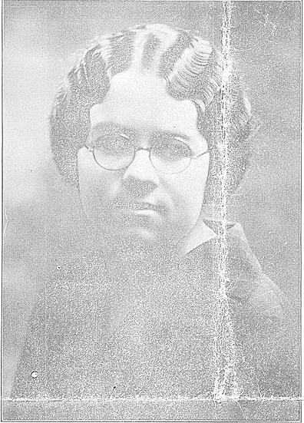

E. IRENE FRITZ

**° TEACHERS' INSTITUTE**

**HELD OCTOBER 5-10**

County Superintendent and Other
  
Good Speakers Address Yearly
  
Gathering of Teachers,

All rural and consolidated school teachers of Griggs county were In attendance at the annual Institute held at the gymnasium from October 5 to 10. The teachers speak highly of the quality of work presented and feel that they received many splen­did Ideas for their year of work.

Business Men Entertain

At a special weleothe the Business Men's Club entertained the teachers and instructors at a "get-together" party on Monday evening. Monroe Borg and Mr. Rogers had charge of the entertainment. The Home Ec­onomics Club served refreshments.

* Good Instructors

Miss Beatrice Johnstone of Grand Forks and Ml's. Simonson of Valley

City were the instructors for the .tveelc. They know country school problems, and the difficulties that the teachers In these schools must face. Therefore, they wore able to give the teachers helpful ideas and methods.

In addition to the reular Instruc­tors, Couny Superintendent Math!Ida Johnson and others addressed the --.ct•TiatFura statini F-itsfis; 4 ;Rat work.

Visit City Schools

While here the visiting teachers were Invited to visit the city schools. Many look advantalge of the oppor­tunity. and attended classes In which they were particularly Interested.

Beneficial Results

This was one of the best institutes ever held in Griggs county. and the teachers returned to their respective schools feeling that the week had been most beneficial to them.

**DEBATE QUESTION FOR**

**H. S. LEAGUE CHOSEN**

"Resolved, That the Trend from local to Federal Control Which Has Characterized Our Government Dm' ing Recent Years, is inimical to t Welfare of the United States." This Is the question which the Buret t • Public Information of 'le University Extension Division, G.and Forks, has determined shall It, the subject cf controversy in tin High School Debating League of North Diikota for 1926.

In order to avoid flea less Citeus Hoe the praseology of the question.

* debating teams shat accept those

ts: Local control • meant to include that wielded by city. town­- 1. county. district r state. The

le "federal" menus the control of the United States government through Congress, th • President, the decision of the Sitpreete Court and by various boards and commis­sions of the federal governntent at Washington. According to the Bu­reau. the expression "during recent years" refers to the period of time beginning some fifteen or twenty years ago, including the present.

Application for entering the 1926 debate contest must be made before the 16th of December. This is earlier than last year. The change Is made In order to pair the teams and to notify them before the Christ-

Continued on Page Three

Miss Rene hit; Selected to Direct
  
Destinies of Society for Coin-
  
ing School Year.

Three years ago,

of '26 were Freshmen. a society of girls was organized in high school and called the Girls' Welfare Society. A society of this nature was des's-

able for promoting co-operation and
  
good feeling among the girls. The

s Senate, a board of six girl members and on faculty member, had up to this tinte attempted to do these things, The board, with the assistance of some women of the community. had made a set of rules which every girl had to follow. Any­one who violated these rules was brought before the Senate and they decided to punish or not to punish the girl. The font of punishment varied with the offense, The objec­tion which the girist raised to this board was that it was too dielatery, SO they would rather have- seine ether' form of Union.

As a e011SESUellee. the Girls Wel­fare Society was organized. II aim­ed to lead and not to dictate. 'rhe society met every oilier Friday. The first part of the meeting was given to business and a program based around some problem which was susgestel by the girls. After the program there was open discussion In which Ml the girls took part. No rules were made by the society le­garding conduct Each girl was to rule her actions by the discussions In the meetings.

During the year the society phut-

**MANY RURAL SCHOOLS**

**TAUGHT BY OLD GRADS**

**•**

Eight graduating classes of Coop­erstown High School are represent­ed In the teaching faculty of the comity. Nearly one•balf of all teach-en; outside the city schools are grad­uates of our high school, a total of 31 claiming this ns their alma mates

* The class of 1923 has the largest representation with 10 members; the class of 1925 comes second with 7 teachers on the list. The class of 1914 is represented by Thelma Ayrea Belling. Esther Skofstad graduated In 1916. Mrs. Oscar Anderson re­mesents the class of 1920. Erma

e\‘‘

Continued on Paige be Ur

**HOME ECONOMICS DEPARTMENT HEARS FINE**

**ADDRESS BY MISS FINLAYSON, STATE DIRECTOR**

**P.-T.A. Meeting to be Hell**

**in the High School Tonight**

The regular meeting of the Cooperstown P.-T. A. will be held at the high school building to­night promptly at S o'clock.

The election of officers Is the main business to be transacted.

The program will be centered around the theme, "Fire Preven­tion." The grade children will present a playlet, "The Trial of lire."

Eight o'clock sharp.

**SUPERINTENDENT HAS**

**GREAT MANY DUTIES**

Wednesday he spoke to the coun­ty institute on the subject of the *N. D.* E. A., urging their member­ship in that organization so that it would he more possible that North Dakota secure the best educational privileges for Its children. Ills ef­forts were rewarded with a 100 per cent enrollment by the teachers.

The same afternoon, the superin­tendent spoke before the W. C. T.U. on the subject "Aims of a True Home." He brought out the Idea that these aims should be founded upon the Ten Commandments. He Illustrated his talk with readings from the poet, Edgar Guest.

Friday morning he addressed the assembly on the Greater North Da­kota Association. The same after­noon he presented the advisability of each school In the county having an exhibit at the Griggs County Fair next June. and showed by examples of work from the local schools what such an exhibit might contain and how it should be organized.

**TAKE UP PROJECT OF**

**MAKING XMAS BOXES**

The grade children throughout the state of North Dakota are mak­ing it a point to sacrifice some of their own abundant little belongings and send to their brothers and sis­ters across the sea in the Ralson states.

The boxes are being filled with toys. pencils, crayons. handkerchiefs and such like articles. Tho boxes are about four and one-half by ten inches so flint when filled they con­tain quite a number of things. The grade children of our schools have been working on a number for about two weeks and have filled five boxes. Mrs. Johnson, county super­intendent of schools, supplied the boxes.

This kind of work is very bene­ficial to the children and should he encouraged.

***Directs Girls' Welfare Society***

mid to pr t or a public program in the middle of the year and a get-together part) OM rho first part or the first term.

The first two years the plan was pmt across w tb great success and

when the cities the regular m dings were very spir­

ited affnirs. Last yeat however. they failed to get their public pro­g•am in because there were so mnny other things going on at the Mlle I Slue.

This year Mim Fritz, the new ad­viser. says that they Intend to pttt their program through and perhaps do more.

They ISO• have plans under way for thew party and a program for theyear which will be put through with as much vigor and snap as pos­sible. if the girls keep It up. the a. W. S. will be une of the school's Most prominent societies.

Suggests Organization of Club in
  
Connection With Department
  
in Local School.

Miss Finlayson, state vocational home economics director, addressed the members of that department in a special assembly on Friday. Oote• her 2nd She began her *address* by saying, "I feel especially interested in Cooperstown Iliglt School because it is in its Infancy of Home Econ­omics training." By this she meant that vocational work has just been adopted and In working but three weeks.

Superintendent Rogers spent a very busy week starting October 5th. In addition to his regular classroom and supervisory duties. he participated in several meetings of local interest.

On Monday evening be had charge of the program of entertainment

ant sponsored by the Business Men's Club, and given to the visiting teachers of the county who were in attendance at the annual institute.

Tuesday evening was the regular Board of Education meeting. Ito is

- the--Dostutma-th
  
transacts all clerical business.

Realm of Homemaking

Miss pinlaysett stated that the realm of homemaking consisted of

family, and keeping the family well. All these essentials are stressed In the course of study offered In the department. However, she added that these were not the only jobs a house­wife has to do, for she must know how to manage, how to darn, how to entertain, and how to care for (lie family in case of Illness. These principles are also stressed in the work of the course.

Value of Course

The speaker emphasized the value of a course in our schools when she stated: "Many a woman has wasted half a lifetime learning how to cook (by experimenting), when she could have kilned the same things It a two year course In a domestic science class in the schools."

"Child care is an essential part of your training," the speaker went on to say. "Yo umay have little

Continued on Page Three

"OLD IRONSIDES" TO BE

RESTORED BY PEOPLE

The "Constitution." one of the first frigates ordered by Congress Is in a deteriorated condition In the Navy yards.

Congress was willing to forward the finances to restore this histor­ical ship to its former condition. On further thought they realized that everyone In the United States would like to have some par in the rebuilding of the famous "Old Iron-sides."

With this object in mind they planned drives to be conducted in all the states.

In our state the quota is small and thus a pleasure to raise. The drive Is being sponsored by the Elks lodge.

From October 1Sth to 24th funds will be received and sent to the di­rectors In charge.

Every high school student Is ask­ed to bring one penny toward the betterment of this cause.

Forming Foundation

"The high school girl," she Con­tinued, "Is young and perhaps far from home making, but every girl has some tasks which can be better accomplished If she has had special training. As you are forming your­selves now, so will you be In life.

By buying and making clothes, by buying and Donating foods, and hr providing safeguards to health you will form a» excellent foCOOPioZIPfor later home-making and honsekeeP• log."