Two days ago the Little Chief claim, adjoining the Little Pittsburg, was purchased by Farwell, Dexter, Cooper and others of Chicago, for $360,000 and the cash paid down.

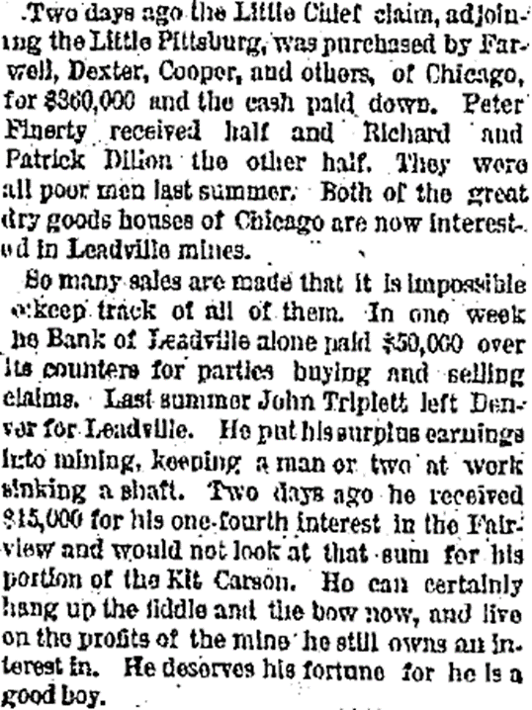

Dec 25, 1878

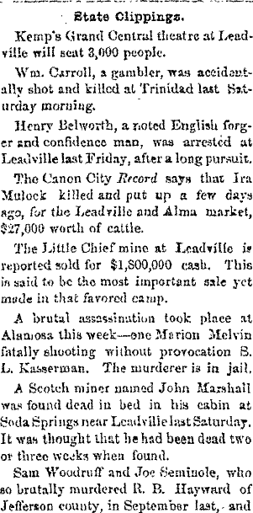

Jan 1, 1880

The Little Chief mine at Leadville is reported sold for $1,800,000 cash.

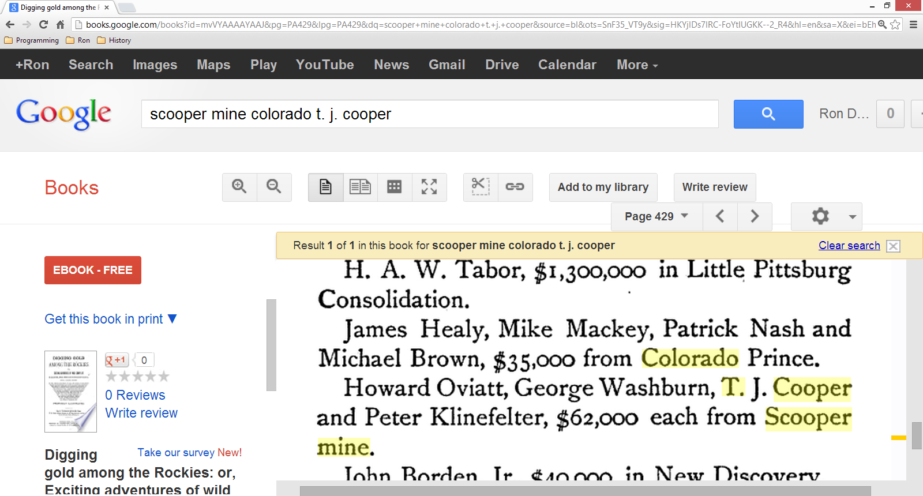

Howard Oviatt, George Washburn, T. J. Cooper and Peter Klinefelter, $62,000 each from Scooper mine.

|  |
| --- |
|  |
| **Public Room** |
| |  | | --- | | http://www.blm.gov/pgdata/libs/CFC/content/statics.0.gif |  |  | | --- | | http://www.blm.gov/pgdata/libs/CFC/content/statics.0.gif |   **Public Room - Information Access Center** 2850 Youngfield Street Lakewood, Colorado 80215 Hours: 9am - 4pm,  Monday - Friday Phone: 303-239-3600 FAX:  303-239-3933  **BLM Colorado**   * [eFOIA/Electronic Reading Room](http://www.blm.gov/co/st/en/BLM_Information/efoia.html)   **Land Records & Plats**   * [Cadastral Survey](http://www.blm.gov/co/st/en/BLM_Programs/geographical_sciences/cadastral.html) * [GeoCommunicator](http://www.geocommunicator.gov/) - publication site for the Bureau of Land Management's National Integrated Land System (NILS) transaction applications  GeoCommunicator [Energy Map Viewer](http://www.geocommunicator.gov/NILS-PARCEL2/map.jsp?MAP=ENERGY) * [Land and Mineral Records System](http://www.blm.gov/lr2000/index.htm) - LR 2000 * [GLO Records](http://www.glorecords.blm.gov/) - Colorado patents, survey plats and notes, and land status records * Land Status Records - [Master Title Plat Legend](http://www.blm.gov/pgdata/etc/medialib/blm/co/resources/land_status_records0.Par.32250.File.dat/Colorado%20Legend%20page%201.tif) and [Abbreviations](http://www.blm.gov/pgdata/etc/medialib/blm/co/resources/land_status_records0.Par.65695.File.dat/Colorado%20Legend%20page%202.tif)   **Maps**   * [GIS](http://www.blm.gov/co/st/en/BLM_Programs/geographical_sciences/gis.html) * [Ordering Maps](http://www.blm.gov/co/st/en/BLM_Resources/public_room/map_info.html) |

Colorado Archives

1313 Sherman, Room 1B20   
Denver, CO 80203   
Phone: 303-866-2358   
Fax: 303-866-2229  
[http://www.colorado.gov/dpa/doit/ar](http://www.colorado.gov/dpa/doit/archives)