http://www.shgresources.com/nd/timeline

* **9,500 BC -** Paleo-Indian peoples initially occupied the Northern Plains, hunting mammoths, giant bison, and other mega-fauna. Mining of Knife River Flint, North Dakota's first export commodity, began in Dunn and Mercer Counties.
* **5,500 BC -** Archaic peoples based their lifeways on hunting and gathering of essentially modern fauna since the previous era's mega-fauna were now extinct. The atlatl, a dart throwing device which drastically increased the range, effectiveness, and safety of hunting, came into use.
* **700 BC -** Ceramics were first used in North Dakota for cooking and food storage.
* **550-410 BC -** Early Woodland peoples living along the James River in Southeastern North Dakota built a log and brush house. Charred grape chenopod (Goosefoot), and Marshelder seeds were found together in the house remains when they were excavated in A. D. 1985.
* **100 BC -** Middle Woodland peoples began building burial mounds in North Dakota, including complex ceremonial centers. The bow and arrow were introduced during this period.
* **AD 30 -** Jamestown mounds, a complex burial and ceremonial site, were occupied.
* **AD 900 -** Late Woodland peoples used the bow and arrow extensively, produced ceramics resembling the later Plains Village wares, and gardened intensively.
* **AD 950 -** Plains Village peoples raised corn and other crops in sufficient quantities to store seed and trade for other goods. Seasonally occupied, permanent villages of earthlodges were built.
* **AD 1200 -** Jamestown mounds site was abandoned.
* **AD 1200-1400 -** 
  + A drought reduced agricultural production and fewer living sites were established on the open prairies. Plains Village peoples abandoned the lower James River area by A.D. 1300.
  + 14th c. Scandinavians in North Dakota?
* **AD 1600 -** The Cheyenne, living in earthlodges, occupied the Sheyenne River valley; the Hidatsa moved west from Devils Lake to the Missouri; the Sioux moved onto the plains from the woodlands of Minnesota.

<http://en.wikipedia.org/wiki/History_of_the_Americas>

http://en.wikipedia.org/wiki/Indigenous_people_of_the_Americas

According to the [New World migration model](http://en.wikipedia.org/wiki/Models_of_migration_to_the_New_World), a migration of humans from [Eurasia](http://en.wikipedia.org/wiki/Eurasia) to the Americas took place via [Beringia](http://en.wikipedia.org/wiki/Beringia), a [land bridge](http://en.wikipedia.org/wiki/Land_bridge) which connected the two continents across what is now the [Bering Strait](http://en.wikipedia.org/wiki/Bering_Strait). The most recent point at which this [migration](http://en.wikipedia.org/wiki/Historical_migration) could have taken place is *c.* 12,000 years ago, with the earliest period remaining a matter of some unresolved contention.[[17]](http://en.wikipedia.org/wiki/Indigenous_people_of_the_Americas#cite_note-jacobs2001-16)[[18]](http://en.wikipedia.org/wiki/Indigenous_people_of_the_Americas#cite_note-jacobs2002-17) These early [Paleo-Indians](http://en.wikipedia.org/wiki/Paleo-Indians) soon spread throughout the Americas, diversifying into many hundreds of culturally distinct nations and tribes.[[18]](http://en.wikipedia.org/wiki/Indigenous_people_of_the_Americas#cite_note-jacobs2002-17) According to the [oral histories](http://en.wikipedia.org/wiki/Oral_history) of many of the indigenous peoples of the Americas, they have been living there since their genesis, described by a wide range of traditional creation accounts.

http://en.wikipedia.org/wiki/Sioux

The name "Sioux" is an abbreviated form of *Nadouessioux* borrowed into [French Canadian](http://en.wikipedia.org/wiki/French_Canadian) from *Nadoüessioüak* from the early [Odawa](http://en.wikipedia.org/wiki/Odawa_language) [exonym](http://en.wikipedia.org/wiki/Exonym): *naadowesiwag* "Sioux".[[8]](http://en.wikipedia.org/wiki/Sioux#cite_note-dict-7) [Jean Nicolet](http://en.wikipedia.org/wiki/Jean_Nicolet) recorded the use in 1640.[[5]](http://en.wikipedia.org/wiki/Sioux#cite_note-Sioux_nation-4) The [Proto-Algonquian](http://en.wikipedia.org/wiki/Proto-Algonquian_language) form *\*na·towe·wa*, meaning "Northern Iroquoian", has reflexes in several daughter languages that refer to a small rattlesnake ([massasauga](http://en.wikipedia.org/wiki/Massasauga" \o "Massasauga), *Sistrurus*).[[9]](http://en.wikipedia.org/wiki/Sioux#cite_note-riggs-8) This information was interpreted by some that the Ottawa borrowing was an insult. However, this Proto-[Algonquian](http://en.wikipedia.org/wiki/Algonquian_languages) term most likely was ultimately derived f

http://en.wikipedia.org/wiki/File:Spreading_homo_sapiens.svg

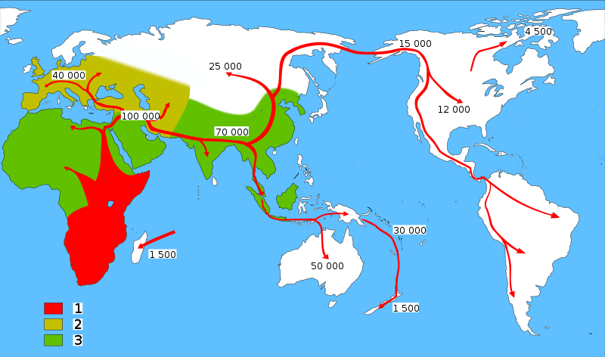rom a form *\*-a·towe·*, meaning simply to "speak foreign language",[[8]](http://en.wikipedia.org/wiki/Sioux#cite_note-dict-7) Later this was extended in meaning in some Algonquian languages to refer to the [massasauga](http://en.wikipedia.org/wiki/Sistrurus_catenatus). Thus, contrary to many accounts, the old Odawa word *naadowesiwag* did not equate the Sioux with snakes. This is not confirmed though, since usage over the previous decades has led to this term having negative connotations to those tribes to which it refers. This would explain why many tribes have rejected this term as an [autonym](http://en.wikipedia.org/wiki/Endonym)