"The Cold War had the distinction of not costing any lives."
- Dr. Edward Teller, father of the hydrogen bomb, New York Times, May 4, 1999
"People don't really understand and know that the Cold War was a real war with real casualties. Real people died."
- Lorna Bourg, sister of a 1958 KIA, Fort Myers, Va., Military Post Chapel, April 2, 1997
"Their names aren't in any history books, and their names aren't on any monuments."
- Greg Skavinski, son of a Cold War casualty, from By Any Means Necessary (2001)
EUROPEAN THEATER: IRON CURTAIN
Date | Location | Name | Service | Unit
Nov 11, 1944 | Yugoslavia, Nis | Brewer, Phil | Air Force | 82nd Fighter Group
Nov 11, 1944 | Yugoslavia, Nis | Coulson, "Sid" | Air Force | 82nd Fighter Group
Dec 24. 1945 | Yugoslavia Border | Shinn. William | Army | E Co., 349th Inf. Regt.
Mar 3, 1946 | Germany, Berlin | Wilson, James | Army | 778th Ordnance Co.. 78th Inf. Div.
Jul 16, 1946 | Yugoslavia Border | Kagawa, Walter L. | Army | 88th Infantry Division
Aug 19, 1946 | Yugoslavia, Bled | Claeys, Richard H. | Air Force | European Air Transport Service
Aug 19, 1946 | Yugoslavia, Bled | Comko, Matthew | Air Force | European Air Transport Service
Aug 19, 1946 | Yugoslavia, Bled | Freestone, Bien L. | Air Force | European Air Transport Service
Aug 19, 1946 | Yugoslavia, Bled | Lower, Chester J. | Air Force | European Air Transport Service
Aug 19, 1946 | Yugoslavia, Bled | Schreiber, Harold F | Air Force | European Air TransportF.Service
Jan 22, 1949 | Greece, Kaperision Lepija | Edner, Seldon R. | Air Force | Joint U.S. MAAG
Apr 8, 1950 | Baltic Sea, Latvia | Beckman, Frank L. | Navy | Det. A, Patrol Squadron 26
Apr 8, 1950 | Baltic Sea, Latvia | Bourassa, Joseph I | Navy | Det. A, Patrol Squadron 26
Apr 8, 1950 | Baltic Sea, Latvia | Burgess, Tommy L. | Navy | Det. A, Patrol Squadron 26
Apr 8, 1950 | Baltic Sea, Latvia | Danens, Joe H., Jr. | Navy | Det. A, Patrol Squadron 26
Apr 8. 1950 | Baltic Sea, Latvia | Fette, John H. | Navy | Det. A, Patrol Squadron 26
Apr 8, 1950 | Baltic Sea, Latvia | Purcell, Edward J. | Navy | Det. A, Patrol Squadron 26
Apr 8, 1950 | Baltic Sea, Latvia | Reynolds, Robert D. | Navy | Det. A, Patrol Squadron 26
Apr 8, 1950 | Baltic Sea, Latvia | Rinnier, Joseph N., Jr. | Navy | Det. A, Patrol Squadron 26
Apr 8, 1950 | Baltic Sea, Latvia | Seeschaf, Howard W. | Navy | Det. A, Patrol Squadron 26
Apr 8. 1950 | Baltic Sea, Latvia | Thomas, Jack W. | Navy | Det. A, Patrol Squadron 26
May 3, 1951 | Austria, Vienna | Gresens, Paul | Army | 796th Military Police Bn.
Sep 2, 1958 | Armenia, Leninakan | Duncan, Paul E. | Air Force | 7406th Support Squadron
Sep 2, 1958 | Armenia, Leninakan | Jeruss, Edward J. | Air Force | 7406th Support Squadron
Sep 2, 1958 | Armenia, Leninakan | Price, Laroy | Air Force | 7406th Support Squadron
Sep 2, 1958 | Armenia, Leninakan | Simpson, John E., | Air Force | 7406th Support Squadron
Sep 2, 1958 | Armenia, Leninakan | Swiestra, Rudy J. | Air Force | 7406th Support Squadron
Sep 2, 1958 | Armenia, Leninakan | Villareal, Ricardo M. | Air Force | 7406th Support Squadron
Sep 2, 1958 | Armenia, Leninakan | Bourg, Archie T. | Air Force | Det. 1, 6911th Radio Sqdn. Mobile
Sep 2, 1958 | Armenia, Leninakan | Ferguson, James E., Jr. | Air Force | Det. 1, 6911th Radio Sqdn. Mobile
Sep 2, 1958 | Armenia, Leninakan | Fields, Joel H. | Air Force | Det. 1. 6911th Radio Sqdn. Mobile
Sep 2, 1958 | Armenia, Leninakan | Kamps, Harold T. | Air Force | Det. 1, 6911th Radio Sqdn. Mobile
Sep 2, 1958 | Armenia, Leninakan | Madeiros, Gerald H. | Air Force | Det. 1, 6911th Radio Sqdn. Mobile
Sep 2, 1958 | Armenia, Leninakan | Maggiacomo, Gerald C. | Air Force | Det. 1, 6911th Radio Sqdn. Mobile
Sep 2, 1958 | Armenia, Leninakan | Mankins. Clement O. | Air Force | Det. 1, 6911th Radio Sqdn. Mobile
Sep 2, 1958 | Armenia, Leninakan | Mello. Arthur L. | Air Force | Det. 1, 6911th Radio Sqdn. Mobile
Sep 2, 1958 | Armenia, Leninakan | Moore, Robert H. | Air Force | Det. 1, 6911th Radio Sqdn. Mobile

VFW © 2004 • Cold War Clashes 149
Sep 2, 1958 | Armenia, Leninakan | Oshinskie, Robert J. | Air Force | Det. 1, 6911th Radio Sqdn. Mobile
Sep 2, 1958 | Armenia, Leninakan | Petrochilos, George P | Air Force | Det. 1, 6911th Radio Sqdn. Mobile
Jul 1, 1960 | Barents Sea, Cape Holy Nose | Goforth, Oscar L. | Air Force | 343rd SRS, 55th Strat. Recon Wing
Jul 1, 1960 | Barents Sea, Cape Holy Nose | Palm, Willard G. | Air Force | 343rd SRS, 55th Strat. Recon Wing
Jul 1, 1960 | Barents Sea, Cape Holy Nose | Phillips, Dean B. | Air Force | 343rd SRS, 55th Strat. Recon Wing
Jul 1, 1960 | Barents Sea, Cape Holy Nose | Posa, Eugene E. | Air Force | 343rd SRS. 55th Strat. Recon Wing
Jan 28, 1964 | East Germany, Erfurt | Hannaford, Gerald K. | Air Force | HQ, USAF. Europe
Jan 28, 1964 | East Germany, Erfurt | Millard. Donald G. | Air Force | HQ, USAF Europe
Jan 28, 1964 | East Germany. Erfurt | Lorraine, John F | Air Force | 7101st Air Base Wing
May 12, 1972 | Germany. Frankfurt | Bloomquist, Paul A. | Army | V Corps
May 24, 1972 | Germany, Heidelberg | Bonner, Clyde R. | Army | U.S. Army, Europe HQ
May 24, 1972 | Germany, Heidelberg | Peck, Charles L. | Army | U.S. Army, Europe HQ
May 24, 1972 | Germany, Heidelberg | Woodward, Ronald A. | Army | U.S. Army, Europe HQ
Dec 23, 1975 | Greece, Athens | Welch. Richard | CIA | Athens Station
Apr 12, 1979 | Turkey, Izmir | Claypool, Edward A. | Air Force | Det. 5, 1141st Spec. Activities Sqdn.
May 11, 1979 | Turkey, Istanbul | Mosley, Thomas D. | Army | Tuslog Detachment 155
Dec 14, 1979 | Turkey, Istanbul | Smith, James E. | Army | HQ Det.. 528th Artillery Group
Apr 16, 1980 | Turkey, Istanbul | Novello, Sam | Navy | Tuslog Detachment 47, JUSMAT
Nov 15, 1980 | Turkey, Adana (Incirlik) | Herrington, William C. | Air Force | Det. 1, 193rd Security Police
Nov 15, 1983 | Greece, Athens | Tsantes, George | Navy | Defense Attaché Office
Mar 24, 1985 | East Germany. Ludwigslust | Nicholson. Arthur D., Jr. | Army | U.S. Military Liaison Mission
Aug 8, 1985 | Germany, Wiesbaden | Pimental, Edward F | Army | 563rd Ordnance Company
Aug 8, 1985 | Germany, Rhein-Main AB | Scarton, Frank | Air Force | 437th Military Airlift Wing
Jun 28, 1988 | Greece, Athens (Kifissia) | Nordeen, William | Navy | Defense Attaché Office
Mar 12, 1991 | Greece, Athens | Steward, Ronald 0. | Air Force | Hellinikon Air Base
 |  | LATIN AMERICA: CACTUS CURTAIN
Apr 19, 1961 | Cuba, Bay of Pigs | Baker. Leo F. | Air Force/CIA | Alabama Air NG (117th TRW)
Apr 19, 1961 | Cuba, Bay of Pigs | Gray, Wade C. | Air Force/CIA | Alabama Air NG (117th TRW)
Apr 19, 1961 | Cuba, Bay of Pigs | Ray. Thomas W. | Air Force/CIA | Alabama Air NG (117th TRW)
Apr 19, 1961 | Cuba, Bay of Pigs | Shamburger, Riley | Air Force/CIA | Alabama Air NG (117th TRW)
Oct 27, 1962 | Cuba, Nipe Bay | Anderson, Rudolph | Air Force/CIA | 4080th Strategic Recon Wing
Jan 10, 1964 | Panama, Canal Zone | Haupt, David J. | Army | 10th IR, 193rd Inf. Bde.
Jan 11, 1964 | Panama, Canal Zone | Aubin, Gerald A. | Army | 10th IR, 193rd Inf. Bde.
Jan 11, 1964 | Panama, Canal Zone | Cruz, Luis Jiminez- | Army | 10th IR, 193rd Inf. Bde.
Apr 30, 1965 | Dominican Republic | Benware, Clifford N., Jr. | Marine Corps | I Co., 3rd Bn., 6th Marines
Apr 30, 1965 | Dominican Republic | Rowe, Russell (1) | Marine Corps | I Co., 3rd Bn., 6th Marines
May 1. 1965 | Dominican Republic | Brown. William H., Ill | Marine Corps | I Co.. 3rd Bn., 6th Marines
May 1, 1965 | Dominican Republic | Kellerman, Gerald S. | Army | 508th Inf., 82nd Airborne
May 1, 1965 | Dominican Republic | Waldron, Robert C. | Army | 17th Cav, 82nd Airborne
May 3, 1965 | Dominican Republic | Bridges, Tripphett L. | Army | C Co., 1st Bn.. 505th Inf., 82nd Abn.
May 3, 1965 | Dominican Republic | Winston, William J. | Army | C Co., 2nd Bn., 325th Inf., 82nd Abn.
May 3, 1965 | Dominican Republic | Feher, Michael | Marine Corps | K Co., 3rd Bn., 6th Marines
May 6, 1965 | Dominican Republic | Duron, Norberto A. | Army | 505th Inf., 82nd Airborne
May 6, 1965 | Dominican Republic | Fuller. Ronald D. | Marine Corps | 3rd Bn.. 10th Marines
May 6, 1965 | Dominican Republic | Roberts, Daniel B. | Marine Corps | 3rd Bn.. 10th Marines
May 6, 1965 | Dominican Republic | Pitts. Frederick G. | Navy | 3rd Bn., 10th Marines
May 10, 1965 | Dominican Republic | Hutchison. Charles T. | Army | 325th Inf., 82nd Airborne
May 12, 1965 | Dominican Republic | Webb, Joe H. | Marine Corps | 1st Bn., 6th Marines
May 13, 1965 | Dominican Republic | Powell, Timothy F | Army | 313th Army Security Agency Bn.
May 13, 1965 | Dominican Republic | Samples, George P | Army | 313th Army Security Agency Bn.
May 17, 1965 | Dominican Republic | Dec, Joseph | Army | 505th Inf., 82nd Airborne Division
May 17, 1965 | Dominican Republic | Lee, James N. | Marine Corps | 2nd Service Battalion
May 19, 1965 | Dominican Republic | Crile. Joseph J. | Marine Corps | 2nd Engineer Battalion

150 Cold War Clashes • VFW © 2004

Jun 16. 1965 | Dominican Republic | Coleman. Lavanda W. | Army | 508th Inf., 82nd Airborne Division
Jun 16, 1965 | Dominican Republic | Gardner, George | Army | 508th Inf., 82nd Airborne Division
Jun 16, 1965 | Dominican Republic | Phelps, Joseph E. | Army | 505th Inf.. 82nd Airborne Division
Jun 16, 1965 | Dominican Republic | Plenty. Joseph S. | Army | 508th Inf., 82nd Airborne Division
Jun 16, 1965 | Dominican Republic | Sneider, Anton C. | Army | 508th Inf., 82nd Airborne Division
Jul 20, 1965 | Guatemala | Hauser, Harold | Army | Military Assistance Advisory Group
Sep 3, 1965 | Dominican Republic | Randall, Raymond, Jr. | Army | 82nd Airborne Division
Sep 14, 1966 | Dominican Republic | Ford, George | Army | HQ Co., Support Unit, 82nd Abn.
Sep 14, 1966 | Dominican Republic | Kreitzman, Ricki L. | Army | HQ Co., Support Unit, 82nd Abn.
Jan 16, 1968 | Guatemala, Guatemala City | Webber, John D., Jr. | Army | Military Assistance Advisory Group
Jan 16, 1968 | Guatemala, Guatemala City | Munro, Ernest A. | Navy | Military Assistance Advisory Group
Oct 12, 1968 | Brazil, San Paulo | Chandler, Charles R. | Army | San Paulo University student
Dec 2, 1979 | Puerto Rico, San Juan | Ball, John R. | Navy | Sabana Seca Communications Stn.
Dec 2, 1979 | Puerto Rico, San Juan | White, Emil | Navy | Sabana Seca Communications Stn.
May 16, 1982 | Puerto Rico. San Juan | Phillips, Darryl T. | Navy | LISS Pensacola
May 25. 1983 | El Salvador. San Salvador | Schaufelberger, Albert, III | Navy | SEAL Adviser
Oct 25, 1983 | Grenada (2) | Cline, Randy E. | Army | 1st Bn.. 75th Rangers
Oct 25, 1983 | Grenada | Maynard, Marlin R. | Army | 1st Bn., 75th Rangers
Oct 25, 1983 | Grenada | Rademacher, Mark A. | Army | 1st Bn., 75th Rangers
Oct 25. 1983 | Grenada | Robinson, Russell L. | Army | 1st Bn., 75th Rangers
Oct 25, 1983 | Grenada | Yamane, Mark O. | Army | 1st Bn.. 75th Rangers
Oct 25, 1983 | Grenada | Lucas, Keith J. | Army | 160th Spec. Ops. Aviation Regt.
Oct 25. 1983 | Grenada | Giguere, John P. | Marine Corps | Helicopter Sqdn. 261
Oct 25, 1983 | Grenada | Scharver, Jeffrey R. | Marine Corps | Helicopter Sqdn. 261
Oct 25, 1983 | Grenada | Seagle, Jeb F. | Marine Corps | Helicopter Sqdn, 261
Oct 26, 1983 | Grenada | Ritz, Michael E | Army | 325th Inf., 82nd Abn. Div.
Jan 11, 1984 | Honduras, Nicaraguan Border | Schwab, Jeffrey C. | Army | 229th Avn. Bn., 101st Avn. Grp.
Sep 1, 1984 | Nicaragua, Santa Clara | Parker, Dana | Private | Civilian Military Assistance
Sep 1. 1984 | Nicaragua, Santa Clara | Powell, James | Private | Civilian Military Assistance
Jun 19, 1985 | El Salvador. San Salvador | Dickson, Bobby J. | Marine Corps | Embassy Security Guard Det.
Jun 19, 1985 | El Salvador, San Salvador | Handwork, Thomas T. | Marine Corps | Embassy Security Guard Det.
Jun 19, 1985 | El Salvador, San Salvador | Kwiathowski, Patrick R. | Marine Corps | Embassy Security Guard Det.
Jun 19, 1985 | El Salvador, San Salvador | Weber, Gregory H. | Marine Corps | Embassy Security Guard Det.
Oct 5, 1986 | Nicaragua | Cooper, William J. | Civilian | Corporate Air Services
Oct 5. 1986 | Nicaragua | Sawyer, Wallace B., Jr. | Civilian | Corporate Air Services
Mar 31, 1987 | El Salvador, El Paraiso | Fronius, Gregory | Army | 7th Special Forces Group
Jan 2, 1991 | Honduras, Rafael Habra | Dawson, Earnest | Army | 228th Aviation Regiment
Jan 2, 1991 | Honduras, Rafael Habra | Pickett, David | Army | 228th Aviation Regiment
Jan 2, 1991 | Honduras, Rafael Habra | Scott, Daniel | Army | 228th Aviation Regiment

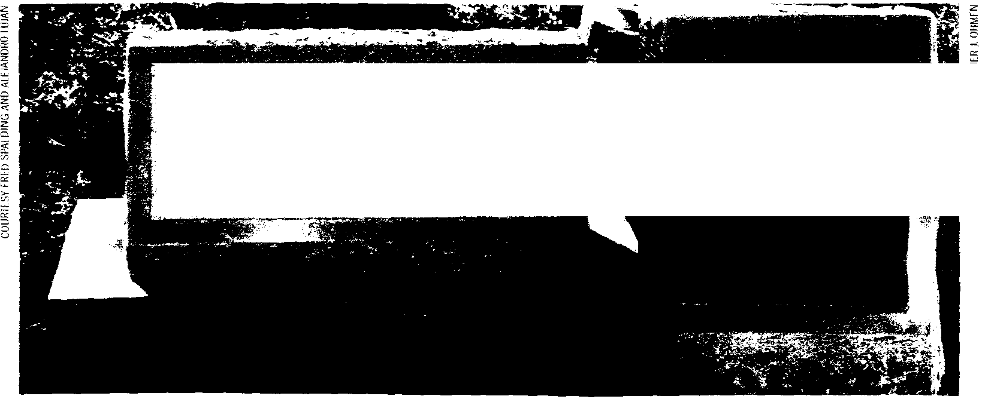


These two memorials honor Americans killed in action in the Dominican Republic in 1965-66. The 82nd Airborne Division memorial (far left) is located at Ft. Bragg, N.C. Members of the 2nd Marine Division killed in that country are remembered at Camp Lejune, N.C.
4N WA : OD Ailt60
WitO WEItVY 01 of THE E ail N ACTION IN TDE pagiswA
PFC ROtERT C W.nLIJRC; I/11TH CAV I MA
WILLIAM J SSINSTI, 3
TRItlIELT L 6RIDCtS 3 MA
? CilAkilS 1 HUTCHISON i - ;2ST INF AY'
c °11 DEC .3iT I. f I tAAY
• EMI I. PHELPS I - ,,n5 J6 314E
4 i A YMeS1) R AND kll. JR I S PT⁻.
VFW © 2004 Cold War Clashes 151

Aug 25, 1945 Sep 26, 1945 Dec 4, 1945 Apr 7. 1946 May 21, 1946 Jul 29, 1946 Jul 29, 1946 Jul 29, 1946 Jul 29, 1946 Sep 30, 1946 Apr 5, 1947 Apr 5, 1947 Apr 5, 1947 Apr 5, 1947 Apr 5, 1947 Dec 25, 1947 Jul 14, 1948 Apr 29, 1949 Dec 4, 1950 Dec 4, 1950 Dec 4, 1950 Dec 4, 1950 Jan 29, 1951 Jan 29, 1951 Apr 21, 1951 Apr 21, 1951 Apr 21, 1951 Apr 21, 1951 Apr 21, 1951 Nov 6, 1951 Nov 6, 1951 Nov 6, 1951 Nov 6, 1951 Nov 6, 1951 Nov 6, 1951 Nov 6, 1951 Nov 6, 1951 Nov 6, 1951 Nov 6, 1951 Jun 13, 1952 Jun 13, 1952 Jun 13, 1952 Jun 13, 1952 Jun 13, 1952 Jun 13, 1952 Jun 13, 1952 Jun 13, 1952 Jun 13, 1952 Jun 13, 1952 Jun 13, 1952 Jun 13, 1952 Oct 7, 1952 Oct 7, 1952
152 Cold War Clashes • VFW © 2004
China, Hsuchow Vietnam, Saigon China, Bob Ban Jon
China, Lutai China, Tientsin China, Anping China, Anping China, Anping China, Anping Philippines, Manila
China, Hsin Ho China, Hsin Ho China, Hsin Ho China, Hsin Ho China, Hsin Ho China, Wang Tan Yeun
Korea, Kaesong Tibet, China Border
China, Andung, Yalu River China . Andung, Yalu River China, Andung, Yalu River China, Andung, Yalu River Philippines, Luzon
Philippines, Luzon Philippines, Cabanatuan Philippines, Cabanatuan Philippines, Cabanatuan Philippines, Cabanatuan Philippines, Cabanatuan
Sea of Japan, off Vladivostok Sea of Japan, off Vladivostok Sea of Japan, off Vladivostok Sea of Japan, off Vladivostok Sea of Japan, off Vladivostok Sea of Japan, off Vladivostok Sea of Japan, off Vladivostok Sea of Japan, off Vladivostok Sea of Japan. off Vladivostok Sea of Japan, off Vladivostok Sea of Japan
Sea of Japan Sea of Japan Sea of Japan Sea of Japan Sea of Japan Sea of Japan Sea of Japan Sea of Japan Sea of Japan Sea of Japan Sea of Japan
Pacific, Kurile Islands
Pacific. Kurile Islands
ASIAN THEATER: BAMBOO CURTAIN
Birch, John Army Air Forces
Dewey, A. Peter Army
Gilbert, James M. Marine Corps
Bobbish, Andrew Marine Corps
Eborn, James D. Marine Corps
Cowin, Douglas A. Marine Corps
Lopez, John U. Marine Corps
Punch, Lawrence F. Marine Corps
Tate, Gilbert R. Marine Corps
?? (could not locate) Army
Di Nenna, Salvator L. Marine Corps
Peloro, John T. Marine Corps
Perkey, Alfred E. Marine Corps
Powroznyk, Joseph D. Marine Corps
Spencer. Frank C. Marine Corps
Brayton, Charles J., Jr. Marine Corps
Labita, Charles Army
MacKiernan, Douglas CIA
Lovewell, John R. Air Force
McDonough, Charles E. Air Force
Picucci, James L. Air Force
Young, Jules E. Air Force
Burns, Walter R. Army
Flack, Kenneth H. Army
Chulosky, Peter Air Force
Embry, Shelby G. Air Force
Fanelli, Joseph C. Air Force
McClain, William A. Air Force
Montgomery, John Air Force
Baggett, Reuben S. Navy
Foster, Paul R. Navy
Hodgson. Judd C. Navy
Juric, Paul G. Navy
Lively, Jack D. Navy
Meyer, William S. Navy
Raglin, Erwin D. Navy
Rosenfeld, Samuel Navy
Smith, Donald A. Navy
Wigert, Ralph A. Navy
Becker, Rosco G. Air Force
Berg, Eddie R. Air Force
Blizzard, William A. Air Force
Bonura, Leon F Air Force
Busch, Samuel N. Air Force
Homer, William R. Air Force
McDonnell, Robert J. Air Force
Monserrat, Miguel W. Air Force
Moore, David L. Air Force
Pillsbury, Danny H. Air Force
Sculley, James A. Air Force
Service, Samuel D. Air Force
Brock, Paul E. Air Force
Colgan, Samuel A. Air Force
Office of Strategic Services Office of Strategic Services 1st Battalion, 29th Marines 1st Battalion, 5th Marines
H & S Co., 1st Marines
1st Bn., 11th Marines
1st Bn., 11th Marines
1st Bn., 11th Marines
1st Bn.. 11th Marines
Military Police (?)
1st Bn., 5th Marines
1st Bn., 5th Marines
1st Bn., 5th Marines
1st Bn., 5th Marines
1st Bn., 5th Marines
H & S Co., 3rd Marines
E Co., 32 Inf., 7th Infantry Division China Station
Det. A, 84th Bomb Squadron Det. A, 84th Bomb Squadron Det. A, 84th Bomb Squadron Det. A, 84th Bomb Squadron
HQ Co.. 29th Eng. Topographical Bn. HQ Co.. 29th Eng. Topographical Bn. 24th Vehicle Repair Squadron
24th Vehicle Repair Squadron 24th Vehicle Repair Squadron 24th Vehicle Repair Squadron 24th Vehicle Repair Squadron Patrol Squadron 6
Patrol Squadron 6
Patrol Squadron 6
Patrol Squadron 6
Patrol Squadron 6
Patrol Squadron 6
Patrol Squadron 6
Patrol Squadron 6
Patrol Squadron 6
Patrol Squadron 6
91st Strategic Recon Squadron 91st Strategic Recon Squadron 91st Strategic Recon Squadron 91st Strategic Recon Squadron 91st Strategic Recon Squadron 91st Strategic Recon Squadron 91st Strategic Recon Squadron 91st Strategic Recon Squadron 91st Strategic Recon Squadron 91st Strategic Recon Squadron 91st Strategic Recon Squadron 91st Strategic Recon Squadron 91st Strategic Recon Squadron 91st Strategic Recon Squadron

Oct 7, 1952 | Pacific, Kurile Islands | Dunham, John R. | Air Force | 91st Strategic Recon Squadron
Oct 7, 1952 | Pacific, Kurile Islands | English, Eugene M. | Air Force | 91st Strategic Recon Squadron
Oct 7, 1952 | Pacific, Kurile Islands | Hirsch, John A. | Air Force | 91st Strategic Recon Squadron
Oct 7, 1952 | Pacific, Kurile Islands | Kendrick, Fred G. | Air Force | 91st Strategic Recon Squadron
Oct 7, 1952 | Pacific, Kurile Islands | Neail, Frank E. | Air Force | 91st Strategic Recon Squadron
Oct 7, 1952 | Pacific, Kurile Islands | Shipp, Thomas G. | Air Force | 91st Strategic Recon Squadron
Nov 29, 1952 | China, Manchuria | Schwartz, Norman A. | CIA | Civil Air Transport
Nov 29, 1952 | China, Manchuria | Snoddy, Robert C. | CIA | Civil Air Transport
Jan 18, 1953 | Formosa Strait, Swatow | Angell, Dwight C. | Navy | Patrol Squadron 22
Jan 18, 1953 | Formosa Strait, Swatow | Beahm, Ronald A. | Navy | Patrol Squadron 22
Jan 18, 1953 | Formosa Strait, Swatow | Byars, Clifford R. | Navy | Patrol Squadron 22
Jan 18, 1953 | Formosa Strait, Swatow | McClure, William F | Navy | Patrol Squadron 22
Jan 18, 1953 | Formosa Strait, Swatow | Morley, Paul A. | Navy | Patrol Squadron 22
Jan 18, 1953 | Formosa Strait, Swatow | Smith, Lloyd | Navy | Patrol Squadron 22
Jul 29, 1953 | Sea of Japan, off Vladivostok | Beyer, Frank E. | Air Force | 343rd Strategic Recon Squadron
Jul 29, 1953 | Sea of Japan, off Vladivostok | Brown, Francis L. | Air Force | 343rd Strategic Recon Squadron
Jul 29, 1953 | Sea of Japan. off Vladivostok | Czyz, Edmund J. | Air Force | 343rd Strategic Recon Squadron
Jul 29, 1953 | Sea of Japan, off Vladivostok | Gabree, Donald W. | Air Force | 343rd Strategic Recon Squadron
Jul 29, 1953 | Sea of Japan, off Vladivostok | Goulet, Roland E. | Air Force | 343rd Strategic Recon Squadron
Jul 29, 1953 | Sea of Japan, off Vladivostok | Keith, James G. | Air Force | 343rd Strategic Recon Squadron
Jul 29, 1953 | Sea of Japan. off Vladivostok | O'Kelley, Stanley K. | Air Force | 343rd Strategic Recon Squadron
Jul 29, 1953 | Sea of Japan, off Vladivostok | Russell, Charles J. | Air Force | 343rd Strategic Recon Squadron
Jul 29, 1953 | Sea of Japan, off Vladivostok | Sanderson, Warren J. | Air Force | 343rd Strategic Recon Squadron
Jul 29, 1953 | Sea of Japan, off Vladivostok | Stalnaker, Robert E. | Air Force | 343rd Strategic Recon Squadron
Jul 29, 1953 | Sea of Japan, off Vladivostok | Tejeda, Francisco J. | Air Force | 343rd Strategic Recon Squadron
Jul 29, 1953 | Sea of Japan, off Vladivostok | Ward, John C. | Air Force | 343rd Strategic Recon Squadron
Jul 29, 1953 | Sea of Japan, off Vladivostok | Wiggins, Lloyd C. | Air Force | 343rd Strategic Recon Squadron
Jul 29, 1953 | Sea of Japan, off Vladivostok | Woods, James E. | Air Force | 343rd Strategic Recon Squadron
Jul 29, 1953 | Sea of Japan. off Vladivostok | Hill, Donald G. | Air Force | 1st Radio Squadron Mobile
Jul 29, 1953 | Sea of Japan, off Vladivostok | Radlein, Earl W. | Air Force | 1st Radio Squadron Mobile
Jan 4, 1954 (3) | Yellow Sea, off Dairen | Archbold, Robert G. | Navy | Patrol Squadron 2
Jan 4, 1954 | Yellow Sea, off Dairen | Beasley, Jesse | Navy | Patrol Squadron 2
Jan 4, 1954 | Yellow Sea, off Dairen | Berger, David B. | Navy | Patrol Squadron 2
Jan 4, 1954 | Yellow Sea, off Dairen | Claussen, Allen R. | Navy | Patrol Squadron 2
Jan 4, 1954 | Yellow Sea, off Dairen | Hand, James F. | Navy | Patrol Squadron 2
Jan 4, 1954 | Yellow Sea, off Dairen | Morelli, Paul D. | Navy | Patrol Squadron 2
Jan 4, 1954 | Yellow Sea, off Dairen | Mulford, Stanley B. | Navy | Patrol Squadron 2
Jan 4, 1954 | Yellow Sea, off Dairen | Prael, Fredrick T. | Navy | Patrol Squadron 2
Jan 4, 1954 | Yellow Sea, off Dairen | Rensink, Loyd B. | Navy | Patrol Squadron 2
Jan 4, 1954 | Yellow Sea, off Dairen | Spicklemier, Gordon | Navy | Patrol Squadron 2
May 6, 1954 | Laos, Ban Sot/Dien Bien Phu | Buford, Wallace A. | CIA | Civil Air Transport
May 6, 1954 | Laos, Ban Sot/Dien Bien Phu | McGovern. James B. | CIA | Civil Air Transport
Sep 3, 1954 | Formosa, Quemoy Island | Lynn, Frank | Army | Military Assistance Advisory Group
Sep 3, 1954 | Formosa, Quemoy Island | Medendorp, Alfred | Army | Military Assistance Advisory Group
Sep 4, 1954 | Sea of Japan | Reid, Rodger H. | Navy | Patrol Squadron 19
Nov 7, 1954 | Sea of Japan. Hokkaido | Angulo, Sigfredo | Air Force | 91st Strategic Recon Squadron
Jan 19, 1955 | Korea DMZ | Glenn, Thomas | Army | American Forces Korea Network
Jan 19, 1955 | Korea DMZ | Pipes, Robert | Army | American Forces Korea Network
Apr 17, 1955 | Bering Sea, off Siberia, Kamchatka | Brooks. Robert N. | Air Force | 4th SRS, 26th Strat. Recon Wing
Apr 17, 1955 | Bering Sea, off Siberia, Kamchatka | Neighbors, Lacie C. | Air Force | 4th SRS, 26th Strat. Recon Wing
Apr 17, 1955 | Bering Sea, off Siberia, Kamchatka | Watkins, Richard E. | Air Force | 4th SRS, 26th Strat, Recon Wing
Aug 17, 1955 | Korea DMZ | Brown, Charles W. | Army | 6148th Tactical Control Squadron
Aug 22, 1956 | East China Sea. off Wenchow | Barber, Donald W. | Navy | Elect. Countermeasures Sqdn. 1
Aug 22, 1956 | East China Sea, off Wenchow | Caron, Warren E. | Navy | Elect. Countermeasures Sqdn. 1

VFW 2004 • Cold War Clashes 153
Aug 22, 1956 | East China Sea, off Wenchow | Curtis, Jack A. | Navy | Elect. Countermeasures Sqdn. 1
Aug 22, 1956 | East China Sea, off Wenchow | Deane, James B. | Navy | Elect. Countermeasures Sqdn. 1
Aug 22, 1956 | East China Sea, off Wenchow | Flood. Francis A. | Navy | Elect. Countermeasures Sqdn. 1
Aug 22, 1956 | East China Sea, off Wenchow | Haskins, William F. | Navy | Elect. Countermeasures Sqdn. 1
Aug 22, 1956 | East China Sea. off Wenchow | Humbert, William M. | Navy | Elect. Countermeasures Sqdn. 1
Aug 22, 1956 | East China Sea, off Wenchow | Hutchinson, Milton | Navy | Elect. Countermeasures Sqdn. 1
Aug 22, 1956 | East China Sea, off Wenchow | Lounsbury, Harold E. | Navy | Elect. Countermeasures Sqdn. 1
Aug 22, 1956 | East China Sea, off Wenchow | Mattin, Albert P. | Navy | Elect. Countermeasures Sqdn. 1
Aug 22, 1956 | East China Sea, off Wenchow | Messinger, Carl E. | Navy | Elect. Countermeasures Sqdn. 1
Aug 22, 1956 | East China Sea. off Wenchow | Ponsford, James W. | Navy | Elect. Countermeasures Sqdn. 1
Aug 22. 1956 | East China Sea. off Wenchow | Powell, Wallace W. | Navy | Elect. Countermeasures Sqdn. 1
Aug 22, 1956 | East China Sea, off Wenchow | Sprinkle, Donald E. | Navy | Elect. Countermeasures Sqdn. 1
Aug 22, 1956 | East China Sea, off Wenchow | Strykowsky, Leonard | Navy | Elect. Countermeasures Sqdn. 1
Aug 22, 1956 | East China Sea, off Wenchow | Young, Lloyd L. | Navy | Elect. Countermeasures Sqdn. 1
Sep 10, 1956 (4) | Sea of Japan | Arrowood, Palmer D. | Air Force | 6091st Recon Squadron
Sep 10, 1956 | Sea of Japan | Beisty, John E. | Air Force | 6091st Recon Squadron
Sep 10, 1956 | Sea of Japan | Fair, Wayne J. | Air Force | 6091st Recon Squadron
Sep 10. 1956 | Sea of Japan | Fees, Rodger A. | Air Force | 6091st Recon Squadron
Sep 10, 1956 | Sea of Japan | Johnson, Raymond D. | Air Force | 6091st Recon Squadron
Sep 10, 1956 | Sea of Japan | Kobayashi, Richard T. | Air Force | 6091st Recon Squadron
Sep 10, 1956 | Sea of Japan | McLaughlin, William J. | Air Force | 6091st Recon Squadron
Sep 10, 1956 | Sea of Japan | Rahaniotes, Peter J. | Air Force | 6091st Recon Squadron
Sep 10, 1956 | Sea of Japan | Taylor, Pat P. | Air Force | 6091st Recon Squadron
Sep 10, 1956 | Sea of Japan | Davis, Bobby R. | Air Force | Det. 1. 6924th Radio Sqdn. Mobile
Sep 10, 1956 | Sea of Japan | Disbrow, Lorin C. | Air Force | Det. 1, 6924th Radio Sqdn. Mobile
Sep 10, 1956 | Sea of Japan | Ellis, William H. | Air Force | Det. 1. 6924th Radio Sqdn. Mobile
Sep 10, 1956 | Sea of Japan | Maxwell, Harry S., Jr. | Air Force | Det. 1, 6924th Radio Sqdn. Mobile
Sep 10, 1956 | Sea of Japan | Sloan, Leo J. | Air Force | Det. 1, 6924th Radio Sqdn. Mobile
Sep 10, 1956 | Sea of Japan | Swinehart, Paul W. | Air Force | Det. 1, 6924th Radio Sqdn. Mobile
Sep 10, 1956 | Sea of Japan | Trias, Theodorus J. | Air Force | Det. 1, 6924th Radio Sqdn. Mobile
Mar 23, 1961 | Laos | Bankowski, Alfons A. | Air Force | Defense (Air) Attaché Office
Mar 23, 1961 | Laos | Garside, Frederick T. | Air Force | Defense (Air) Attaché Office
Mar 23. 1961 | Laos | Magee. Ralph W. | Air Force | Defense (Air) Attaché Office
Mar 23, 1961 | Laos | Matteson, Glenn | Air Force | Defense (Air) Attaché Office
Mar 23, 1961 | Laos | Sampson. Leslie V. | Air Force | Defense (Air) Attaché Office
Mar 23, 1961 | Laos | Weston, Oscar B., Jr. | Air Force | Defense (Air) Attaché Office
Mar 23, 1961 | Laos | Weitkamp, Edgar W. | Army | Defense Attaché Office
Apr 20, 1961 | Korea DMZ | Anderson. DeLynn E. | Air Force | 6146th Air Force Advisory Group
Apr 22, 1961 | Laos | Biber, Gerald M. | Army | 7th Special Forces Group
Apr 22, 1961 | Laos | Bischoff, John M. | Army | 7th Special Forces Group
Apr 22, 1961 | Laos | Moon, Walter H. (5) | Army | 7th Special Forces Group
Apr 6, 1962 | Laos | Britton, Milton D. | Air Force | Det. 6, 1173rd Foreign Mission Sqdn.
Oct 3, 1962 | Korea DMZ (6) | Rimer, Richard J. | Army | B Btry.., 6th Bn., 15th Arty, 7th ID
Nov 20, 1962 | Korea DMZ | Johnson, James A. | Army | A Troop. 9th Cav, 1st Cav Division
Jul 29, 1963 | Korea DMZ | Dessert, Charles T., III | Army | A Troop, 9th Cav, 1st Cav Division
Jul 29, 1963 | Korea DMZ | Seiler. David A. | Army | A Troop, 9th Cav, 1st Cav Division
Jul 30, 1963 | Korea DMZ | Larion, George F., Jr. | Army | HHB Btry.., 6th Bn., 80th Arty, 7th ID
Nov 2, 1966 | Korea DMZ | Benton, John W. | Army | 23rd Regt., 2nd Infantry Division
Nov 2, 1966 | Korea DMZ | Burrell, Robert W. | Army | 23rd Regt., 2nd Infantry Division
Nov 2, 1966 | Korea DMZ | Fischer, Morris L. | Army | 23rd Regt., 2nd Infantry Division
Nov 2, 1966 | Korea DMZ | Hasty, Leslie L. | Army | 23rd Regt., 2nd Infantry Division
Nov 2, 1966 | Korea DMZ | Hensley, James | Army | 23rd Regt.. 2nd Infantry Division
Nov 2, 1966 | Korea DMZ | Reynolds. Ernest D. | Army | 23rd Regt.. 2nd Infantry Division
Feb 12. 1967 | Korea DMZ | Tyler. Press, Jr. | Army | 23rd Regt., 2nd Infantry Division

154 Cold War Clashes • VFW © 2004
May 22, 1967 | Korea DMZ | Mueller, Carl R. | Army | 23rd Regt., 2nd Infantry Division
May 22, 1967 | Korea DMZ | Smith. Baron J. | Army | 23rd Regt., 2nd Infantry Division
Jul 16. 1967 | Korea DMZ | Ashforth, Leonard | Army | 23rd Regt., 2nd Infantry Division
Jul 16. 1967 | Korea DMZ | Boyd, Tommy D. | Army | 23rd Regt., 2nd Infantry Division
Jul 16, 1967 | Korea DMZ | Gibbs, John L. | Army | 23rd Regt., 2nd Infantry Division
Aug 10, 1967 | Korea DMZ | Boudreaux. Philip | Army | 31st Regt., 7th Infantry Division
Aug 10, 1967 | Korea DMZ | Czaplicki, Donald J. | Army | 31st Regt., 7th Infantry Division
Aug 10, 1967 | Korea DMZ | Skaggs, Jerry D. | Army | 31st Regt., 7th Infantry Division
Aug 22, 1967 | Korea DMZ | Cook, Billy J. | Army | 23rd Regt., 2nd Infantry Division
Aug 28, 1967 | Korea DMZ | Rivers, Curtis, Jr. | Army | 76th Eng. Bn., 2nd Eng. Group
Aug 28, 1967 | Korea DMZ | Vogel, Michael E. | Army | 76th Eng. Bn., 2nd Eng. Group
Aug 29, 1967 | Korea DMZ | Corp, Philip N. | Army | 38th Regt., 2nd Infantry Division
Aug 29, 1967 | Korea DMZ | Lund, Paul G. | Army | 38th Regt., 2nd Infantry Division
Aug 29, 1967 | Korea DMZ | McKee, Edgar A., Jr. | Army | 38th Regt., 2nd Infantry Division
Oct 7, 1967 | Korea DMZ | Arcemont, Terry G. | Army | 2nd Infantry Division
Jan 23, 1968 | Sea of Japan, off N. Korea | Hodges, Duane D. | Navy | USS Pueblo
Jan 24, 1968 | Korea DMZ | Martin, Paul W. | Army | 23rd Regt, 2nd Infantry Division
Jan 26, 1968 | Korea DMZ | Mojica, Salvator T. | Army | 72nd Armor, 2nd Infantry Division
Apr 14, 1968 | Korea DMZ | Anderson, James L. | Army | U.S. Army Support Group, JSA
Apr 14, 1968 | Korea DMZ | Wood, Larry M. | Army | U.S. Army Support Group, JSA
Apr 21. 1968 | Korea DMZ | Bisbee, Robert R. | Army | 31st Regt., 7th Infantry Division
Jul 20, 1968 | Korea DMZ | Weeks, James L. | Army | 2nd Infantry Division
Jul 20, 1968 | Korea DMZ | Holmdahl, Jan S. | Army | 7th Infantry Division
Jul 30, 1968 | Korea DMZ | Rymarczuk, Michael | Army | 23rd Regt., 2nd Infantry Division
Aug 5, 1968 | Korea DMZ | Peterson, Terrance A. | Army | 38th Regt., 2nd Infantry Division
Aug 18, 1968 | Korea DMZ | Bass, Joseph A. | Army | 32nd Regt., 7th Infantry Division
Aug 18. 1968 | Korea DMZ | Hopkins, Jerry L. | Army | 32nd Regt., 7th Infantry Division
Sep 27. 1968 | Korea DMZ | Cayer, Joseph E., Jr. | Army | 2nd Infantry Division
Sep 27, 1968 | Korea DMZ | Reynolds, Michael B. | Army | 2nd Infantry Division
Oct 5, 1968 | Korea DMZ | Nassani, Stephen A. | Army | 2nd Infantry Division
Oct 23, 1968 | Korea DMZ | Turner, David L. | Army | 38th Regt., 2nd Infantry Division
Mar 15, 1969 | Korea DMZ | Lindsey, Calvin L. | Army | 23rd Regt., 2nd Infantry Division
Apr 14, 1969 | Sea of Japan. off Chongjin, N. Korea | Balderman, Louis E | Navy | Fleet Recon Squadron 1
Apr 14. 1969 | Sea of Japan. off Chongjin, N. Korea | Chartier. Stephen C. | Navy | Fleet Recon Squadron 1
Apr 14, 1969 | Sea of Japan. off Chongjin, N. Korea | Colgin, Bernie J. | Navy | Fleet Recon Squadron 1
Apr 14, 1969 | Sea of Japan, off Chongjin, N. Korea | Connors, Ballard F, Jr. | Navy | Fleet Recon Squadron 1
Apr 14, 1969 | Sea of Japan, off Chongjin, N. Korea | Dzema, John N. | Navy | Fleet Recon Squadron 1
Apr 14, 1969 | Sea of Japan, off Chongjin. N. Korea | Gleason, Dennis B. | Navy | Fleet Recon Squadron 1
Apr 14, 1969 | Sea of Japan, off Chongjin. N. Korea | Graham, Gene K. | Navy | Fleet Recon Squadron 1
Apr 14, 1969 | Sea of Japan, off Chongjin, N. Korea | Greiner, La Verne A. | Navy | Fleet Recon Squadron 1
Apr 14. 1969 | Sea of Japan, off Chongjin, N. Korea | Horrigan, Dennis J. | Navy | Fleet Recon Squadron 1
Apr 14, 1969 | Sea of Japan, off Chongjin, N. Korea | Kincaid, Richard H. | Navy | Fleet Recon Squadron 1
Apr 14, 1969 | Sea of Japan, off Chongjin, N. Korea | McNamara, Marshall H. | Navy | Fleet Recon Squadron 1
Apr 14, 1969 | Sea of Japan, off Chongjin, N. Korea | McNeil, Timothy H. | Navy | Fleet Recon Squadron 1
Apr 14, 1969 | Sea of Japan, off Chongjin, N. Korea | Overstreet, James H. | Navy | Fleet Recon Squadron 1
Apr 14, 1969 | Sea of Japan, off Chongjin, N. Korea | Perrottet, Peter P | Navy | Fleet Recon Squadron 1
Apr 14, 1969 | Sea of Japan, off Chongjin, N. Korea | Prindle, Richard T. | Navy | Fleet Recon Squadron 1
Apr 14, 1969 | Sea of Japan, off Chongjin, N. Korea | Ribar, Joseph R. | Navy | Fleet Recon Squadron 1
Apr 14, 1969 | Sea of Japan, off Chongjin. N. Korea | Roach, James L. | Navy | Fleet Recon Squadron 1
Apr 14, 1969 | Sea of Japan, off Chongjin, N. Korea | Singer, John H. | Navy | Fleet Recon Squadron 1
Apr 14, 1969 | Sea of Japan, off Chongjin. N. Korea | Sweeney, Richard E., Jr, | Navy | Fleet Recon Squadron 1
Apr 14. 1969 | Sea of Japan, off Chongjin, N. Korea | Sykora, Robert J. | Navy | Fleet Recon Squadron 1
Apr 14. 1969 | Sea of Japan. off Chongjin. N. Korea | Wilkerson, Norman E. | Navy | Fleet Recon Squadron 1
Apr 14, 1969 | Sea of Japan, off Chongjin, N. Korea | Willis, David M. | Navy | Fleet Recon Squadron 1

VFW C. 200-:
Apr 14, 1969 | Sea of Japan, off Chongjin, N. Korea | DuCharme, Gary R. | Navy | Naval Security Group
Apr 14, 1969 | Sea of Japan, off Chongjin, N. Korea | Lynch, Hugh M. | Marine Corps | Naval Security Group
Apr 14. 1969 | Sea of Japan, off Chongjin, N. Korea | Miller, John A. | Navy | Naval Security Group
Apr 14, 1969 | Sea of Japan, off Chongjin, N. Korea | Potts, John H. | Navy | Naval Security Group
Apr 14, 1969 | Sea of Japan, off Chongjin, N. Korea | Randall, Frederick A. | Navy | Naval Security Group
Apr 14, 1969 | Sea of Japan. off Chongjin, N. Korea | Smith, Richard E. | Navy | Naval Security Group
Apr 14, 1969 | Sea of Japan, off Chongjin, N. Korea | Sundby, Philip D. | Navy | Naval Security Group
Apr 14, 1969 | Sea of Japan, off Chongjin, N. Korea | Taylor, Robert F. | Navy | Naval Security Group
Apr 14, 1969 | Sea of Japan, off Chongjin, N. Korea | Tesmer, Stephen J. | Navy | Naval Security Group
Oct 18, 1969 | Korea DMZ | Grimes, William E. | Army | C Co., 1st Bn., 32nd Inf., 7th ID
Oct 18, 1969 | Korea DMZ | Grissinger, James R. | Army | C Co., 1st Bn., 32nd Inf., 7th ID
Oct 18, 1969 | Korea DMZ | Morris, Jack L. | Army | C Co., 1st Bn., 32nd Inf., 7th ID
Oct 18, 1969 | Korea DMZ | Taylor, Charles E., Jr. | Army | C Co., 1st Bn., 32nd Inf., 7th ID
Nov 6, 1969 | Philippines, Clark Air Base | Agrigado, Gary | Air Force | 604th Military Airlift Support Sqdn.
Nov 6, 1969 | Philippines, Clark Air Base | Dimico, Lorin M. | Air Force | 604th Military Airlift Support Sqdn.
Nov 6, 1969 | Philippines, Clark Air Base | Dunn, John E. | Air Force | 604th Military Airlift Support Sqdn,
Apr 13, 1974 | Philippines, Subic Bay | Dobler, Leland | Navy | Mobile Const. Bn. 133
Apr 13, 1974 | Philippines, Subic Bay | Jeffries, Charles | Navy | Mobile Const. Bn. 133
Apr 13, 1974 | Philippines, Subic Bay | Mitchell, Thomas J. | Navy | 30th Naval Const. Regt.
Nov 20, 1974 | Korea DMZ | Ballinger, Robert M. | Navy | UNC Armistice Affairs Division
Aug 18, 1976 | Korea DMZ | Barrett, Mark T. | Army | US Army Support Group, JSA
Aug 18, 1976 | Korea DMZ | Bonifas, Arthur G. | Army | US Army Support Group, JSA
Jul 14, 1977 | Korea DMZ | Haynes, Robert C. | Army | 17th Aviation Group
Jul 14, 1977 | Korea DMZ | Miles, Joseph A. | Army | 17th Aviation Group
Jul 14, 1977 | Korea DMZ | Wells, Ronald E. | Army | 17th Aviation Group
Dec 6, 1979 | Korea DMZ | Anderson, Thomas L. | Army | 2nd Infantry Division
Oct 28, 1987 | Philippines, Angeles City | Davis, Randy | Air Force | 3rd Component Repair Squadron
Oct 28. 1987 | Philippines, Angeles City | Faust, Stephen M. | Air Force | 3rd Security Police Squadron
Apr 21, 1989 | Philippines, Quezon City | Rowe, James | Army | Joint U.S. Military Adv. Group
May 4, 1990 | Philippines, Olongapo, Subic Bay | Fredette, John | Marine Corps | Marine Fighter/Attack Sqdn. 323
May 13, 1990 | Philippines, Manila, Clark A.B. | Green, James | Air Force | 8th Aircraft Generation Squadron
May 13, 1990 | Philippines, Manila, Clark A.B. | Raven, John | Air Force | 8th Aircraft Generation Squadron
Dec 17, 1994 | Korea DMZ | Hilemon, David W. | Army | A Co., 4th Bn., 501st Aviation Regt.
 | AFRICA AND MIDDLE EAST: DESERT AND JUNGLE CURTAINS
Aug 2, 1958 | Lebanon, Beirut | Nettles, James R. | Army | HQ Co., Task Force 201
Jul 26, 1964 | Congo, Kamina (Katanga) | Merriman, John G. (7) | CIA | "Congolese Air Force"
Jan 11, 1971 | Eritrea, Asmara-Massawa | Echeandia, Richard | Army | MP Guard Company
Jun 2, 1973 | Iran, Teheran | Hawkins, Lewis | Army | Military Assistance Advisory Group
Feb 14, 1976 | Angola, Cuimba | Bacon, George, Ill | Ex-CIA | Private
Apr 15, 1984 | Namibia, Oshakati | Crabtree, Kenneth | Army | Liaison, Joint Military Commission

1 This is the date he was fatally wounded. He actually died in Walter Reed Army Medical Center on June 19, 1965.
2 Navy SEALs Kenneth Butcher, Kevin Lundberg, Stephen Morris and Robert Schamberger drowned,' Rangers Philip Grenier, Kevin Lannon and Stephen Slater as well as paratrooper Gary Epps died accidentally; and Sean Luketina died from "friendly fire."
3 According to the Navy, "Three Cape Cod" (a P2V-5 aircraft) was lost due to mechanical failure. But author William E. Burrows in By Any Means Necessary (pp. 161-6) says it was almost undoubtedly attacked by Chinese MiG-15s ..."
4 Officially, the aircraft was lost in Typhoon Emma. Author William Burrows believes "it was almost certainly attacked by Soviet MiGs" (p. 214).
5 This was the date he was captured. He was executed in Communist captivity on July 22, 1961.
6 Other DMZ lists erroneously carry three additional GI deaths when they were actually killed by "friendly fire." Also, on March 15, 1969, a helicopter evacuating wounded GIs accidentally crashed, killing 6 aboard.
7 He actually died on Aug. 20, 1964.
OPPOSITE PAGE (CLOCKWISE FROM TOP): The National Security Agency Cryptologic Memorial at Fort Meade, Md., was made public on Sept. 2, 1997. The Cold War Submarine Memorial at Patriots Point Naval & Maritime Museum in Mt. Pleasant, S.C., was dedicated Dec. 6, 2002. The Reconnaissance Memorial on the grounds of L-3 Communications Integrated Systems in Greenville, Texas, was dedicated Oct. 9, 1998.
156 Cold War Clashes • VFW © 2004

CHINESE CIVIL WAR (1945-1949)
DMZ DUTY: Infantrymen of the famed 2nd Infantry ("Indianhead") Division at Observation Post Dort on the lookout for North Korean infiltrators in 1967. From 1966-69, 44 U.S. soldiers were killed in action in or near the DMZ by North Koreans in what was referred to as the "Second Korean War."
Bamboo Curtain
ASIA
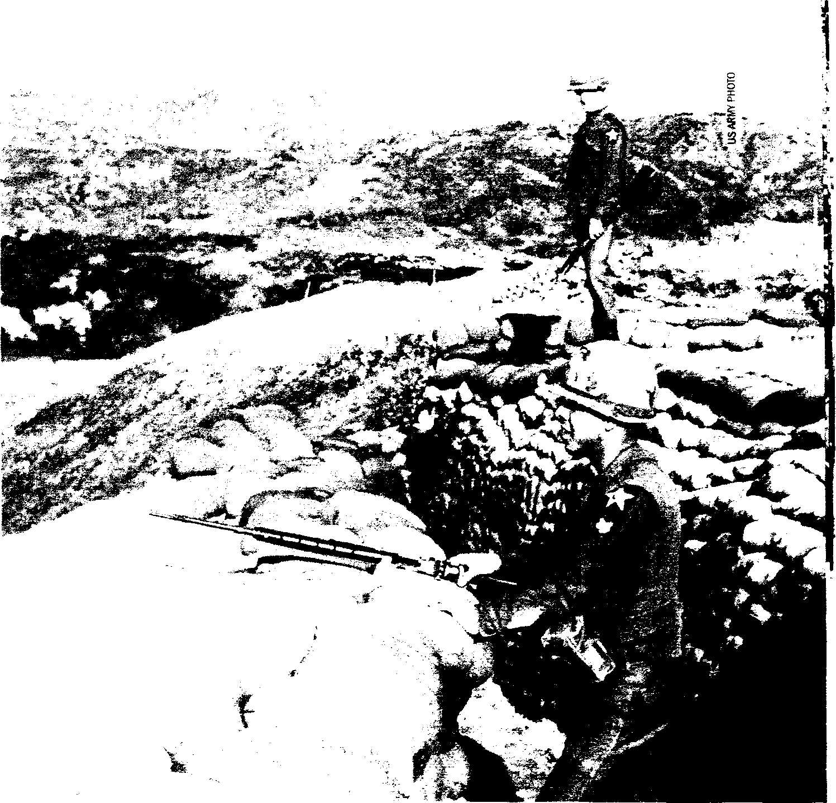
1945 Aug 25 China. First American KIA of the Cold War.
Army Air Forces Capt. John Birch, then an OSS operative, is killed by Communists near Hsuchow.
Sep 2-16 China. Soviet fighters fire on U.S. 7th Fleet air patrols in Manchurian airspace.
Oct China. III Marine Amphibious Corps peaks at 45,000 men. Part of U.S. effort to disarm Japanese.
Oct 6 China. Tientsin. 3 men of the 1st Marines WIA in an attack by 50 Communists.
Oct 18 China. Langfang-Peking. Marines kill 6 Communists in a train-related firefight.
Oct 22 China. Hulutao. U.S. Navy barge is hit by Chinese Communist rifle fire. USS Seize is raked by 35 minutes of machine gun fire. Seize returns .50-caliber machine gun and 40mm cannon fire.
Dec 4 China. Anshan. 1 man of the 29th Marines is KIA. In reprisal, Marines lob 24 60mm mortar rounds into the village concealing the Communists.
Dec 8 China. Shantung. 10 Marine aviators die when 6 dive bombers crash in a snowstorm.
1946 Apr 7 China. Lutai. Marine hunting party attacked by
Communists. U.S.) 1 KIA.
May 21 China. Tientsin. 1 Marine of recon party KIA when attacked by 75 Communists.
Jul 29 China. Battle of Anping. 300 Communists attack Marine motor convoy. 4-hour firefight ensues. U.S.: 4 KIA, 11 WIA. Chinese: 12 KIA.
1947 Apr 5 China. Tangku. Battle of Hsin Ho. At the ammo
supply point, 350 Communists hit the 1st Battalion, 5th Marines, in the "most punishing attack" of the North China operation. Marines: 5 KIA, 16 WIA. Chinese: 6 KIA, 25 WIA.
Jun 19 China. Tsingtao. Pile Point. USS Deliver comes under Communist fire. Destroyers Bennerand Hawkins provide covering fire for a landing force.
Sep 10 China. Goose Point. U.S. Navy rescue party, attempting to recover a downed Marine pilot, is fired upon. Chinese: 3 WIA.
Dec 25 China. Tayu. Chinese Communists capture 5 Marines, killing 1 and later releasing 4.
Dec 29 China. Marine plane crashes: 4-man crew is captured (released July 1948).
1948 Jan 31 China. Tskankou Airfield. Last Marine firefight.
Patrol pinned down by Communists. No casualties.
Oct 19 China. Tsingtao. Navy plane crashes: 2 aviators held POW for 19 months.
1949 Apr 20 China. Hospital ship USS Repose corpsmen and
stretcher bearers from the 3rd Marines assist wounded crew of the British ship Amethysrwhen it is attacked on the Yangtze River by Communists.
May 26 China. C Co., 7th Marines—the last U.S unit—departs China aboard the light cruiser USS Manchester Total U.S. casualties in North China: 14 KIA, 42 WIA in 26 armed encounters. Communists (confirmed): 33 KIA, 30 WIA. 22 Marines die in aircraft crashes.
1945 Aug 29 Korea. Hamhung. 100 mi. north of 38th parallel.
Soviet Yaks force down a U.S. B-29 dropping supplies to a POW camp. Crew survives. First postwar Soviet attack on U.S. aircraft. Moscow claims mistaken identity.
Sep 9-10 Korea. Inchon. U.S. XXIV Corps (6th, 7th & 40th divisions) lands for occupation duty. U.S. troops peak at 72,360. Soviet 25th Army occupies North Korea. Sep 26 Vietnam. Saigon. OSS operative Capt. A. Peter Dewey KIA. In Vietminh ambush.
Oct 15 'fielicv,)Sea. Off Manchuria, Port Arthur. Soviets fire or LI S. New PBM Mariner—first such attack on a S recon aircraft.
1946 Aug 12 Korea. Yohyon-Ni. 3 GIs (32nd Infantry
Regiment) are captured by Soviets and held for 13 days. Sep 30 Philippines. Manila. Ft. McKinley. 19 U.S MPs engage 35-40 Huks (Filipino Communists) in a 45-min. firefight. U.S 1 KIA, 1 WIA.
1948 Jul 14 Korea. Kaesong. 1 GI of E Co., 32nd IR, 7th ID, is
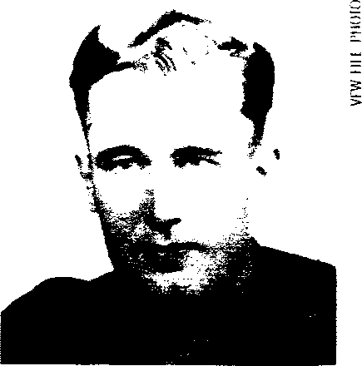
KIA: Air Force Capt. Charles McDonough and three other crew members died when their RB45 spy plane was shot down by Soviets over North Korea on Dec. 12, 1950.
KIA in an ambush near outpost or Ongjin Peninsula.
Sep 15 Korea. Napan. 36 GIs of the 7th ID are killed in e train wreck. Sabotage is ruled out.
Oct 20-21 Korea. Sunchon. NKs besiege Presbyterian Mission occupied by 2 U.S. advisers and 6 civilians.
1949 Feb 19 Korea. Kaesong. NKs shoot down U.S.
observation plane: pilot WIA.
Apr 29 Tibet. 1 CIA agent is killed by Tibetans.
Jun 30 Korea. Last U.S. unit-5th Regimental Combat Team—departs, leaving behind only a 472-man Korean Military Advisory Group (KMAG).
1950-1953 Korea. Manchurian Border. MiG Alley. America wages a secret air war with Soviet pilots. Soviets: 300 KIA. U.S.. 100s of airmen KIA.
1950 Dec 12 Korea. Yalu River. Soviets shoot down an
RB-45C (91st SIRS)) 4 KIA.
1951 Jan 29 Philippines. Luzon. 2 GIs of HQ Co., 29th
Engineer Topographical Bn., and 1 U.S civilian are killed by Communist Huks while surveying.
Apr 21 Philippines. Cabanatuan. 5 airmen of 24th
Vehicle Repair Squadron KIA in Huk ambush.
Nov 6 Sea of Japan. Off Siberia. Soviet fighters shoot down a P2V (VP-6): 10 KIA.
1952 Jun 13 Sea of Japan. Soviets shoot down an RB-29
(91st SAS)) 12 KIA.
Oct 7 Pacific. Kurile Islands. Soviet fighters shoot down an RB-29 (91st SRS): 8 KIA.
Nov 29 China. Manchuria. Chinese shoot down a CIA plane: 2 KIA + 2 POW.

VFW © 2004 Colo War Clashes 159

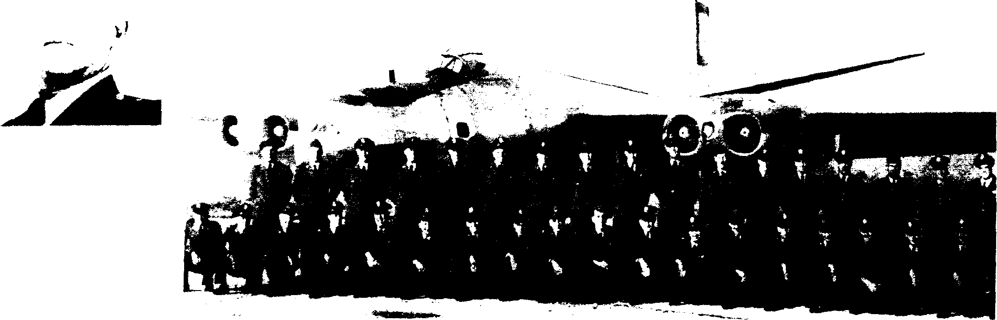

1953 Jan 18 Formosa Strait. Off Swatow. Chinese shore
. -
tia 1 1 V (AMIN⁻1W
RED ALERT: Gun crews aboard the USS Helena keep a sharp watch within 10 miles of Red China's coast as they escort a Nationalist Chinese convoy to besieged Quemoy Island, Sept. 6-7, 1958.
SPIES IN THE SKY: Members of the 91st Strategic •• Recon Wing in the Far East during the early 1950s.
KIA: Army Col. James Rowe was assassinated by NPA Communists in the Philippines on April 21, 1989.
IA() rrilri Al,.' Clorknr .1/C1A/ /7", int-1,1
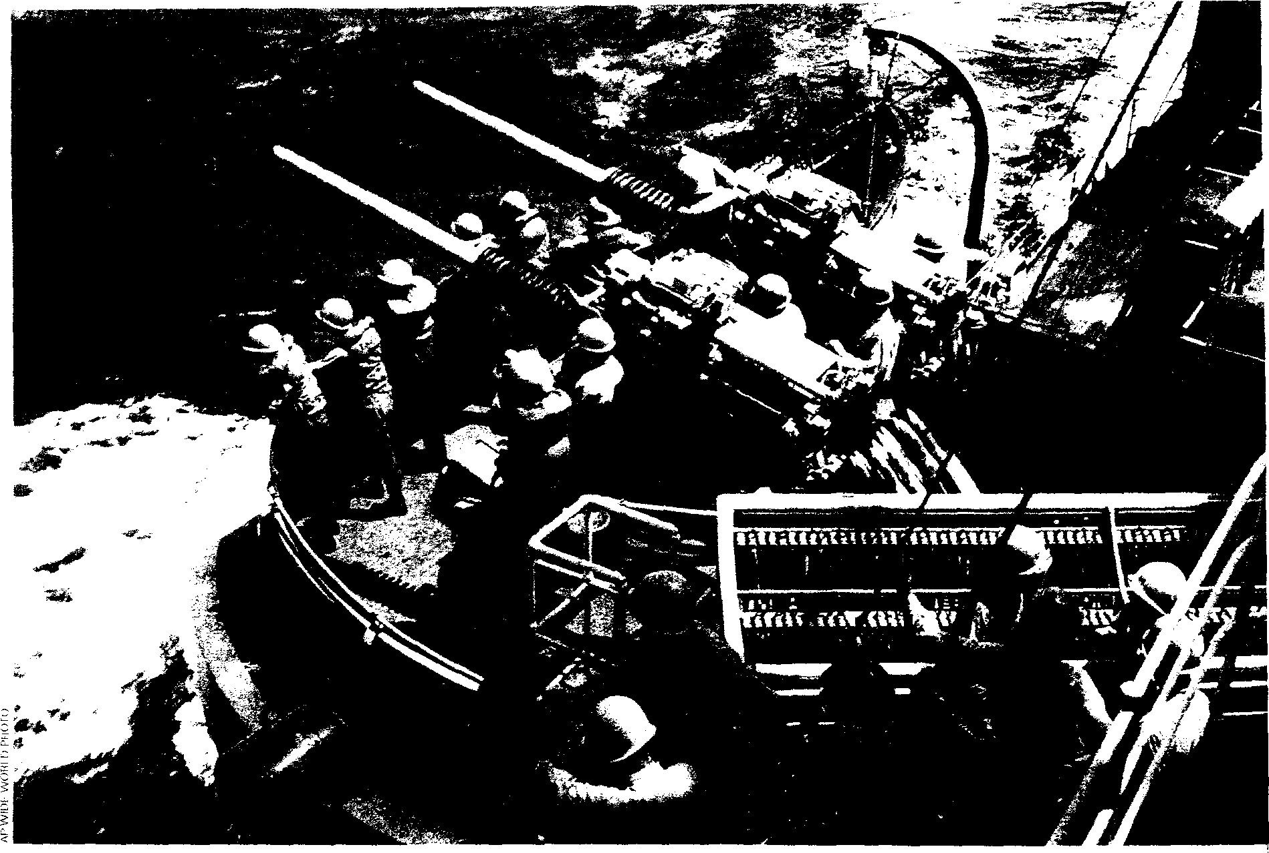
KIA: Capt. John Dunham's RB-29 was shot down by Soviet fighters over the Soviet Far East on Oct. 7, 1952. He was among 8 KIA.
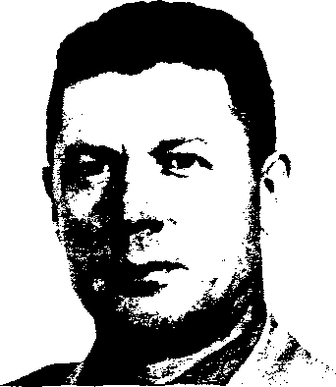
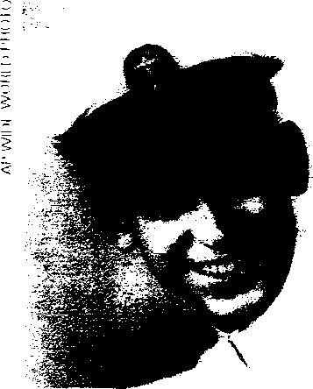
batteries shoot down a P2V (VP-22): 6 KIA. 5 Coast Guardsmen die in a flying-boat crash during search.
Jul 29 Sea of Japan. Soviet fighters shoot down an RB50 (343rd SRS): 16 KIA.
1954 Jan 4 Yellow Sea. Off Dairen. Navy plane of VP-2 lost:
KIA: Lt. Col. Alfred Medendorp was killed during an artillery attack by the Red Chinese on Quemoy Island in the Formosa Strait on Sept. 3, 1954.
10 killed.
Jan 15 Korea. Inchon Harbor. An LCM and LST collide, killing 27 Marines of 3rd Bn., 4th Regt. and 2 corpsmen. May 6 Laos. Bon Sot. 2 CIA pilots of Civil Air Transport KIA near Dien Bien Phu.
Sep 3 Formosa. Quemoy Island. Communist shelling kills 2 U.S. MAAG officers.
Sep 4 Sea of Japan. Soviets shoot down a P2V-5 (VP19): 1 KIA.
Nov 7 Sea of Japan. Soviets shoot down an RB-29 (91th SRS): 1 KIA.
1955 Jan 19 Korea DMZ. NKs shoot at and hit an Army L-20
"Beaver": 2 KIA.
Feb 5 Yellow Sea. Off Korea. RB-45 (6021st RS, 91st SAW) is attacked. Dogfight ensues between 12 Chinese MIG-15s and 8 escorting U.S. F-86s (4th Fighter-interceptor Wing): 2 MiGs shot down.
Aug 17 Korea DMZ. NKs shoot down a U.S. T-6 trainer (6148th TCS): 1 KIA.
1956 Aug 22 China Coast. Off Wenchow. Chinese shoot down a
P4M (VO-1): 16 KIA.
Sep 10 Sea of Japan. During a recon mission, an RB-50 (6091st RS) is lost: 16 killed. Possibly attacked by Soviet fighters. Other accounts attribute loss to weather.
1957 Aug 19 Siberia. Off Vladivostok. USS Gudgeon is depth-
charged for 48 hours by 8 Russian destroyers.
1958 Mar 6 Korea DMZ NKs shoot down a U.S. F-86 jet. Pilot
bails out and is returned.
Oct 1 Taiwan. Between Taipei and Matsu Island. 4 U.S. servicemen and their PBY Catalina flying boat "Blue Goose" vanish without a trace.
1958-1962 Formosa Strait. A U.S. 4-ship destroyer division (based at Kaohsiung) patrols off China's coast.
1959 Sep 24 Japan. Fusigama. U-2A (WRSP-3) crashes.
1961 Apr 20 Korea DMZ. 1 officer of the 6146th Air Force Advisory
Group is KIA when his plane is attacked by NKs.
Mar 23 Laos. Plain of Jars. U.S. plane shot down by Pathet Lao: 7 KIA.
Apr 22 Laos. 3 Green Berets KIA.

1962 Jan 28 Laos. 1 Green Beret KIA.
VFW C 2004 ' Cold War Clashes 161
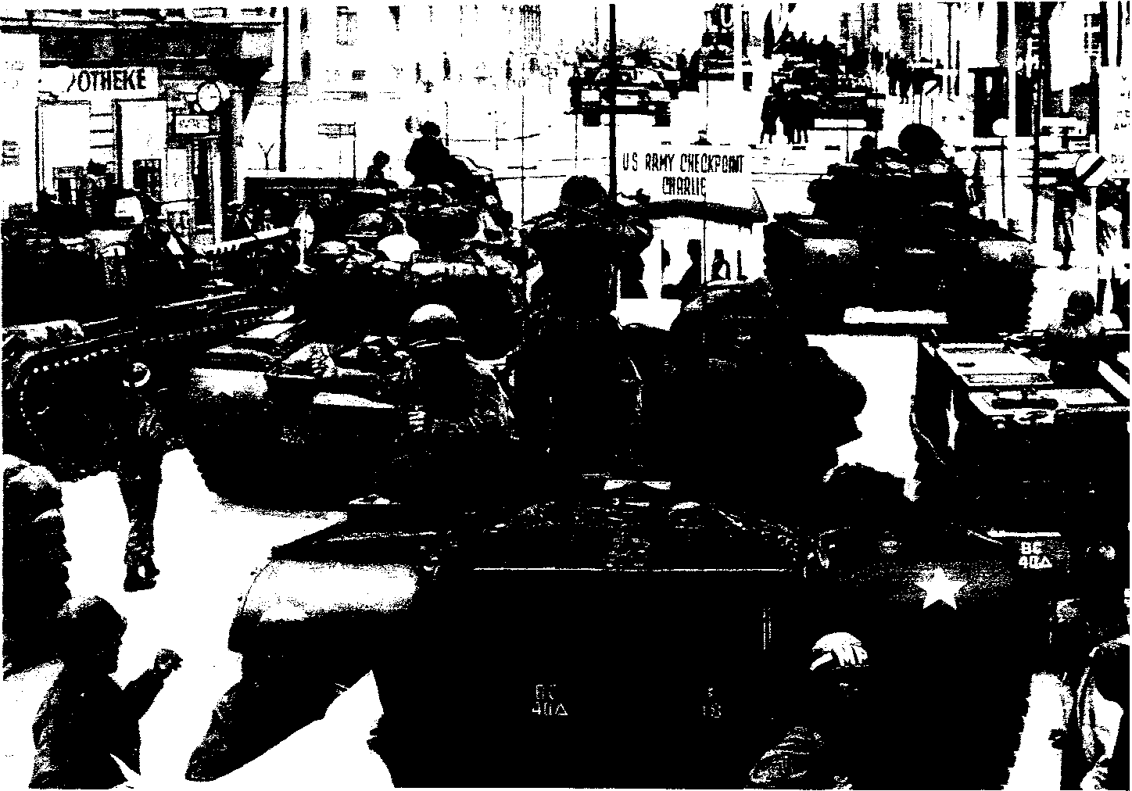
STANDOFF AT CHECKPOINT CHARLIE by Don Stivers. The Berlin Crisis of 1961 found U.S. troops facing off against Soviet tanks on Oct. 26. F Company, 40th Armor, stood them down for 16 hours in the German city.
Apr 6 Laos.1 U.S. airman KIA.
May-Aug Thailand. 5,000 U.S. troops are deployed to
counter Laotian Communist troops at border.
Oct3 Korea DMZ. Hyang Yang. First GI is KIA on DMZ since the end of the Korean War. A soldier of B Bty., 6th Bn., 15th FA, 7th ID, is shot while on guard duty.
Nov 20 Korea DMZ Outpost Susan. 1 GI of A Trp., 1st Recon Sqdn., 9th Cav, 1st CD, is KIA.
1963 May 17 Korea DMZ. 8th Army OH-23 helicopter is shot
down by NKs: 2 pilots held POW for 1 year.
Jul 29-30 Korea DMZ 2 men of 1st CD and 1 of 7th ID are KIA in NK ambushes.
Aug 4 Korea DMZ. 13 men of 1st Recon Sqdn., 9th Cav, 1st CD, engage in 2-hr. firefight with NKs.
Aug 4 Korea. U.S Army light plane crashes in South: 6 soldiers die in accident.
Fall North Pacific. USS Swordfish is depth-charged by Soviet destroyers for 2 days.
1965 Sep 24 Japan. Kami Seya. 12 men of the Naval
Security Group perish in a fire.
1966 Nov 2 Korea DMZ "Second Korean War." 6 GIs of
the 1st Bn., 23rd IR, 2nd ID, are KIA in a NK ambush, initiating 3 years of skirmishing in the DMZ.
1967 Jul 16 Korea DMZ Ambush: 3 KIA of 2nd ID.
Aug 10 Korea DMZ. Ambush: 3 KIA, 16 WIA of 7th ID.
Aug 29 Korea DMZ. Mines: 3 KIA of 2nd ID.
1968 Jan 23 Korea. 82-man crew of the spy ship Pueblo is
captured off the North and held as POW for 11 months. 1 sailor was KIA in the ship's seizure.
Mar Pacific. USS Halibut locates a sunken Soviet sub. Apr2 Korea DMZ Hostile-fire pay is authorized for GIs serving north of the Irnjin River. By this time since 1966, 24 Americans had already been KIA & 71 WIA.
SHOULDER PATCH: U.S. troops served in Berlin—the epicenter of the Cold War—for 45 years as a symbol of resolve against Soviet expansion.
KIA: Lt. James Wilson became the first confirmed hostile fatality of the Cold War in Germany when he was shot to death by a Soviet sentry in Berlin on March 3, 1946.
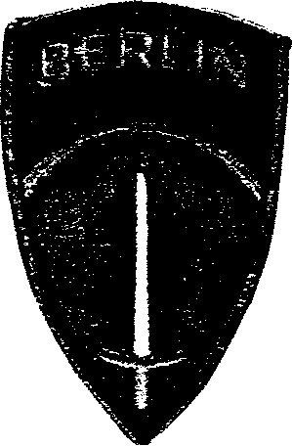

Iron Curtain
EUROPE
1944 Nov 7 Yugoslavia. First Hostile Encounter of the
Cold War. Incident at Nis. P-38s from U.S. 82nd Fighter Group squadrons mistakenly attack a Soviet column, killing 31 Soviet soldiers on the ground. They then shoot down 3 Soviet fighters. 2 U.S. pilots KIA: Lts. Phil Brewer & "Sid" Coulson.
1945 May 8-Nov 30 Czechoslovakia. U.S. troops, peaking
at 22,023 in September, face off against the Soviets along a 266-mile demarcation line in Bohemia. May 23-Jun 14 Yugoslavia Border. U.S. 85th ID
moves into the Italian province of Venezia Giulia along the Morgan Line to counterbalance the Communist Yugoslavian 4th Army. It remains on a 23-day alert status. 91st, 34th and 10th Mountain divisions also serve in the area.
Oct3 Yugoslavia Border 88th ID takes over U.S. sector of Morgan Line.
Dec 23 Germany Berlin. 2 GIs of the 78th ID are killed near Tempelhof Airport. Assailants are not identified or apprehended.
Dec 24 Yugoslavia Border 1 GI of E Co., 349th IR, is killed by Yugoslav partisans.
1946 Feb 9 Soviet Union. Stalin effectively declares
war on the West. He does so in a Moscow speech. Feb 10 Czechoslovakia. 12 Americans infiltrate on an intelligence mission-3 are captured and held for 21 days. 1 GI of the 126th Combat Engineer Battalion earns a Soldiers Medal for heroism.
Mar 3 Germany. Berlin. 1 Army ordnance officer is killed by a Soviet sentry.
Jul 12 Yugoslavia Border Firefight at Ursina. 8-man squad from L Co., 351st IR, is ambushed. Yugoslays: 2 KIA.
Jul 16 Yugoslavia Border 1 GI is killed along a road from Trieste by Yugoslav Partisans.
Aug 9 Yugoslavia Border Ljubljana. U.S. C-47 transport is forced down by Yugoslav aircraft: 7 airmen briefly held captive. B-17s begin flying the route, with gunners ordered to "shoot if interfered with." B-17 flights end Oct. 23.
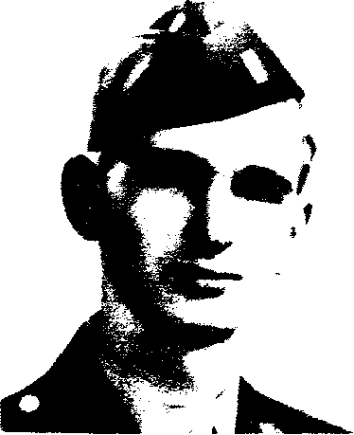
Jun 6 Pacific. S. of Philippines. A-12 (9th SRW) crashes.
1969 Mar 15 Korea DMZ 4-hr. firefight: 1 GI of the 2nd ID is
KIA. The helicopter evacuating the casualties crashes, killing the 2 WIA and 5 crewmen.
Apr 14 Sea of Japan. Off North Korea, Chongjin. Worst Single KIA Loss of the Cold War. NK MiG-15s shoot down a Navy EC-121 (VQ-1) 31 KIA.
Aug 17 Korea DMZ NKs shoot down U.S. helicopter of 59th Avn. Co.: 3 WIA and held POW for 108 days.
Oct 18 Korea DMZ Ambush: 4 GIs of 7th ID are KIA. "Second Korean War": Total U.S. casualties (1966-69): 42 KIA, 111 WIA in DMZ on the ground. 211 non-hostile deaths occur in accidents, etc.
Nov 6 Philippines. Near Clark Air Base. 3 U.S. airmen of the 604th Military Airlift Support Squadron are executed by NPA. Their remains are located Jan. 8, 1971.
1970 Apr2 Philippines. Clark Air Base. 2 U.S. airmen are
executed by Communist NPLA.
Jun 24 Siberia. USS Tautog collides with a Soviet sub 50 miles off Kamchatka Peninsula.
1974 Apr 13 Philippines. Subic Bay Naval Base. 3 U.S Navy
Seabees are killed by Communist NPA.
Nov 20 Korea DMZ 1 U.S. Navy officer killed by a booby-trap in a tunnel.
1976 Aug 18 Korea DMZ 2 U.S. Army officers are murdered
in the "tree-trimming" incident.
1977 Jul 14 Korea DMZ NKs shoot down a helicopter of the
17th Aviation Group: 3 KIA.
1979 Dec 6 Korea DMZ 1 GI (2nd ID) is KIA in a minefield.
1987 Oct 28 Philippines. Angeles City. 2 U.S. airmen and 1
military retiree are KIA by NPA.
1989 Apr 21 Philippines. Quezon City. 1 U.S. Army officer is
KIA by NPA.
1990 May 4 Philippines. Olongapo. Subic Bay. 1 Marine is
KIA by NPA.
May 13 Philippines. Clark Air Base. 2 U.S airmen are KIA by NPA.
1991 Oct 4 Korea DMZ Guard Post Collier. Last Gls-3rd
Plt., A Co., 1st Bn., 503rd IR, 2nd ID—are withdrawn from the 1-mile U.S. sector of the DMZ.
1994 Dec 17 Korea DMZ Last U.S. KIA in Korea: Army
helicopter pilot David Hilemon of A Co., 4th Bn., 501st
Avn Begs. is shot down by NKs.

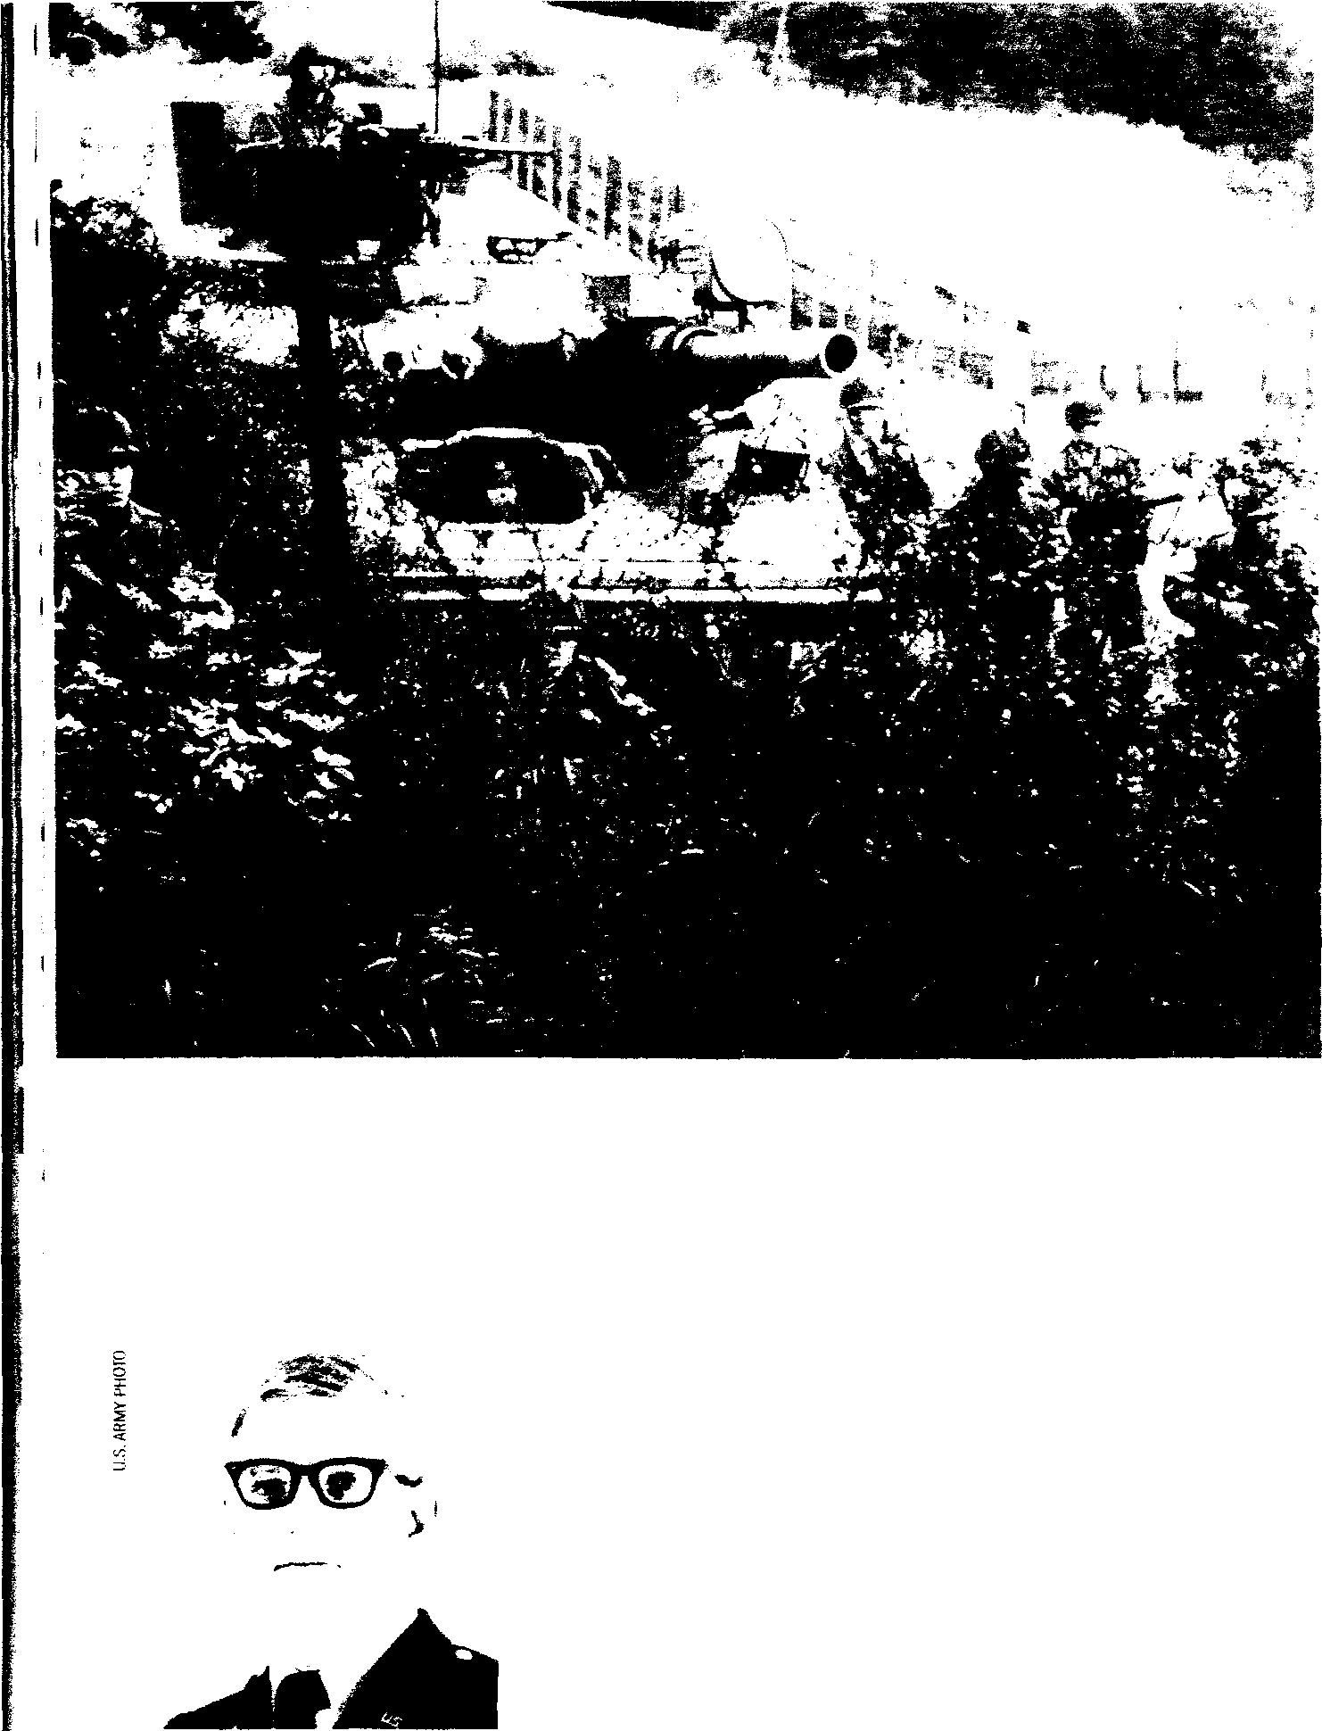
1946 Aug 19 Yugoslavia Border U.S. plane of the ETS is shot
IRON CURTAIN PATROL: U.S. armored cavalry units patrol the East German and Czech borders. Starting with the Constabulary outfits, famous regiments such as the 2nd, 3rd, 6th, 11th and 14th ACRs saw service along the "Iron Curtain" that separated the West from the Communist East.
down by a Yugoslav plane, killing the 5-man crew and causing an international incident.
Oct Yugoslavia Border 88th ID (11,352 men) is the only division in the entire U.S. Army at full operational strength, as a result of tensions with the Yugoslays.
1947 Mar 12 Europe. Truman Doctrine. U.S. officially declares "war" on Soviet expansion and subversion. Sep 15 Yugoslavia Border Outpost 5. 3 GIs of B Co., 351st IR, are captured by Partisans and held for 5 days.
1948 Jul 8-Jul 12, 1949 Germany Berlin. Berlin Airlift. 31 U.S. airmen die in 12 accidental aircraft crashes during Operation Vittles between these dates. 733 incidents of Soviet harassment in the air reported.
KM. Maj. Arthur D. Nicholson, Jr., was the last American killed by Soviet hostile action in Europe. He was shot to death by a Soviet sentry in Ludwigslust, Germany,
on March 24, 1985.
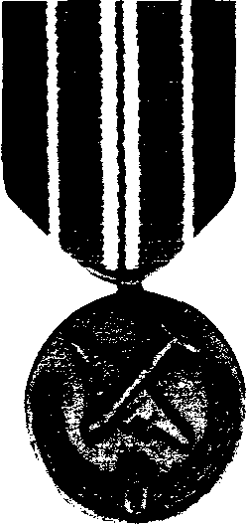
The Medal for Humane Action was awarded to veterans of the Berlin Airlift, 1948-49.
Jul 17 Britain. 60 B-29 bombers of SAC's 28th & 307th
BGs arrive at Marham Royal Air Force Base.
Oct 30 Austria. Vienna. 1 U.S. diplomat is abducted and beaten to death by Soviet NKVD.
Dec 10 Czechoslovakia. Ceska Kubie. 2 GIs of the 6th
ACR are captured and not released until February 1949.
1949 Jan 22 Greece. 1 U.S. Air Force officer is captured and
killed by Communist guerrillas after his AT-6 is shot down by ground fire as he directed a strafing mission.
Aug 24 Greenland Sea off Norway. USS Cochino, a diesel sub, sinks following a battery explosion. 1 civilian from Cochino and 6 sailors from USS Tusk are lost at sea.
1950 Apr 8 Baltic Sea. Latvia. Soviet fighters shoot down a
PB4Y (Det. A, Patrol Squadron-26): 10 KIA.
May 18 Azores. Lajes AB. B-29 crashes: 16 crewmen die.
1951 Mar 7 Mediterranean Sea. A PB4Y2 of VP-26 crashes
(mechanical failure) off Italy. 8 crewmen drown.
May 3 Austria. Vienna. 1 soldier of the 796th MP Battalion is killed by two Soviet soldiers.
1952 Apr 26 Atlantic. USS Hobson collides with the carrier
Wasp: 176 destroyermen die.
1953 Mar 10 Germany. Regensburg. F-84 of the 36th Tactical
Fighter Wing is shot down by 2 Czech MiG-15s in German airspace. Pilot parachutes safely.
1954 Aug 12 Czechoslovakia. Czechs shoot down 2 U.S
trainer planes: Pilots are held until fall. 1955 Aug 11 Germany Karlsruhe. 2 C-119s collide, killing 56
soldiers of A Co.• 499th Eng. Bn.. 555th Eng. Grp., and 10 crewmen from the 10th TCS• 60th TCG.
1956 Oct 23 Germany. Hungarian Uprising. U.S. 3rd ACR
on full alert for a week, moves to the German border. Nov 17 Germany Kaiserslautern. U-2A (WRSP-1) explodes in mid-air: pilot dies.
1957 Dec 23 Albania. U.S. T-33 is shot down: pilot survives.
1958 Aug 2 Lebanon. Beirut. 1 GI of Army Task Force 201 is
KIA by Muslim snipers. 4 U.S servicemen die in accidents during Operation Bluebat• launched to pre-empt Soviet interference in the region.
Sep 2 Soviet Union. Armenia. Worst Single Cold War Hostile Loss in Europe: 17 KIA. 4 Soviet MiGs shoot down an Air Force recon plane of the 7406th Support Squadron, killing 6 crewmen and 11 members of the USAF Security Service's Det 1, 6911th Radio Group Mobile. A C-118 was shot down over Armenia on June
1959 27: All 7 crewmen were released July 7.
May 29 Iceland Coast. USS Grenadierforces a Soviet sub to the surface for the first time ever.
1960 May 1 Russia. Sverdlovsk. (WRSR-21 is downed by
a missile over Ural Mts. Pilot held until Feb. 10, 1962. May 25 Germany U.S. C-47 is shot down over the East: All 9 aboard survive. They are released July 19.
Sep 2 Germany. Grafenwoehr. An errant artillery round kills 16 and wounds 26 men of D Trp.• 3rd Recon Sqdn., 12th Cav, 3rd AD, during Operation Winter Shield,
1961 Jan 15 Atlantic. 75 miles east of Barnegat Island.
"Texas" Tower 4 (designed to warn of a bomber attack) sinks during a storm: 28 die —14 airmen + 14 civilians. Aug 20 Germany. Berlin. Berlin Crisis. 1st BG, 18th IR (1,500 men), convoys along the Helmstedt-Berlin autobahn in a show of force in response to the erection of the Berlin Wall 7 days earlier.
Oct 26 Germany. Berlin. Checkpoint Charlie. F Co., 40th Armor, backed by E Co., 2nd BC, 6th IR, stands down Russian tanks for 16 hours.
Dec 4 Armed Forces Expeditionary Medal is created by executive order to recognize vets of Cold War operations.
1962 May 22 Germany Munich. A mid-air aircraft explosion
claims 26 lives: 22 men of VD-2 + 4 Army specialists.
1963 Apr 10 Atlantic. 220 miles east of Boston. USS
Threshersinks, after a piping failure, with 129 men: 112 crew members + 17 civilian workers die.
1964 Jan 28 Germany East. Erfurt. Soviet fighters shoot
down a U.S. T-39 training plane of the Wiesbaden Air Base Group: 3 KIA.
Mar 10 Germany Gardeiegen. U.S RB-66110th TRW) is shot down: The 3 crewmen survive.
1965 Dec 14 Soviet Union, Black Sea. Soviets shoot down an
RB-5717407th CSS): 2 KIA.
1966 Jan 16 Spain, Palomores. B-52 collides with K-135
tanker while refueling. 7 men die.
1968 May 27 Atlantic. Off Azores. USS Scorpion sinks with
crew of 99. Cause unknown.
Aug 20 Germany. Czechoslovakia Invasion. U.S. 2nd ACR goes on alert when Warsaw Pact forces invade during the Prague Spring.
1970 Oct 21 Soviet Union. Armenia. Soviets shoot down an
Air Force U-8.4 crewmen survive.
1972 May 12 Germany Frankfurt. Red Army Faction (German
Marxist terrorists) explodes a bomb at V Corps HQ: 1 KIA, 13 WIA.
May 24 Germany Heidelberg. Marxist RAF bombs U.S. Army HO: 3 KIA, 5 WIA.
1973 Jun 2 Iran. Teheran. 1 U.S. MAAG officer is KIA by
Iranian Communists.
Oct 6 Mediterranean Sea. 6th Fleet on Defense Condition 3 Alert for 26 days in response to Soviet moves during Arab-Israeli war. U.S. Navy tracks 26 Soviet subs.
1975 May 29 Germany Winterberg. U-2 (349th SRS) crashes. Dec 23 Greece. Athens. CIA operative is assassinated by Greek Communists.

162 Cold War Clashes VFW © 2004

1977 Dec 7 Cyprus. Akrotiri. U-2 (99th SRS) crashes on take-
KIA: Maj. Rudolph Anderson was the only
hostile casualty of the
Cuban Missile Crisis. His U-2 spy plane was downed by a Soviet missile on Oct. 27, 1962.
VFW © 2004 • Cold War Clashes 163
KIA: Thomas W. Ray was one of four CIA-contracted pilots killed during the Bay of Pigs invasion of Cuba in April 1961.
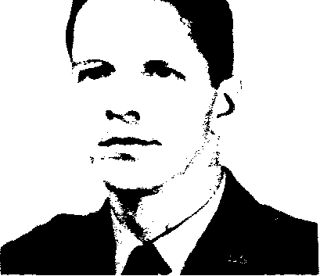
CARIBBEAN UNREST: Paratroopers of the 82nd Airborne Division take cover from sniper fire during the 1965 Dominican Republic intervention. A total of 27 GIs were killed in action by Marxist rebels.
Cactus Curtain
LATIN AMERICA
1961 Apr 19 Cuba, Bay of Pigs. 6,000 U.S. sailors and
Marines cover the Cuban exile invasion. 4 CIA-contracted U.S pilots from the Alabama Air National Guard are KIA.
1962 Oct 14-28 Cuba. Missile Crisis. 30,000 U.S. sailors
and aviators aboard 63 vessels participate in the blockade. SAC is placed on full alert: 70 B-52s airborne, fully armed. 5,750 Marines are based at Guantanamo. Oct 23 Cuba. Guantanamo BavLeeward Point. C-135 cargo plane crashes: 7 crewmeri die.
Oct 27 Cuba. Nipe Bay. Soviet missile downs a U-2 (SAC's 4080th SRW): 1 KIA. He (posthumously) is the first to ever receive the Air Force Cross.
Oct 27 Bermuda. Kindley AB. An RB-47, while taking off on a recon mission, crashes 4 airmen die.
Nov 20 Florida. Off Key West. U-2 (4028th SRS) crashes. Little known U-2 operations are conducted from McCoy AFB in Florida for overflights of Cuba.
1964 Jan 10-11 Panama. Canal Zone. Cristobal. Firefight at
Masonic Temple. 3rd Plt., C Co., 4th Bn., 10th IR, 193rd IB, engages Panamanian rioters who support Cuba's Fidel Castro. U.S.: 3 KIA, 16 WIA.
May 3 Cuba. Guantanamo Bay. 5 U.S sailors stumble into and die in the base's minefields. (Before perimeter minefields are finally cleared 35 years later, 13 men of the Marine !Minefield Maintenance Platoon die.)
Jul 19 Cuba. Guantanamo Bay. Marines shoot and kill 2 Cuban soldiers on base perimeter.
1965 Apr 24 Dominican Republic Intervention.
Operation Power Pack is launched to thwart Communist-led rebels. U.S. forces peak at 30,522: 20,463 (12,439 soldiers; 6,924 Marines; 1.100 airmen) ashore and 10,059 sailors offshore.
Jun 15-16 Dominican Republic. Battle of Santo Domingo City. Bloodiest engagement of intervention involves 82nd AD. U.S.: 5 KIA, 31 WIA. Rebels: 67 KIA, 165 WIA.
.Jul 20 Guatemala. 1 U.S. helicopter pilot is killed by Guatemalan guerrillas.1 U.S. MAAG colonel later slain.
1966 May 22 Cuba. Guantanamo Bay. Marines kill a Cuban.
Jul 28 Bolivia. U-2 (4080th SRW) crashes: pilot dies.
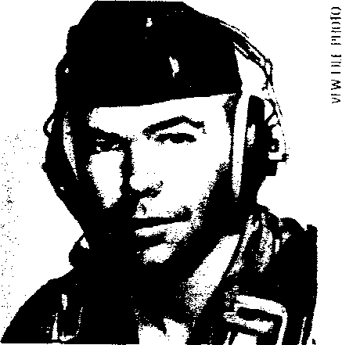

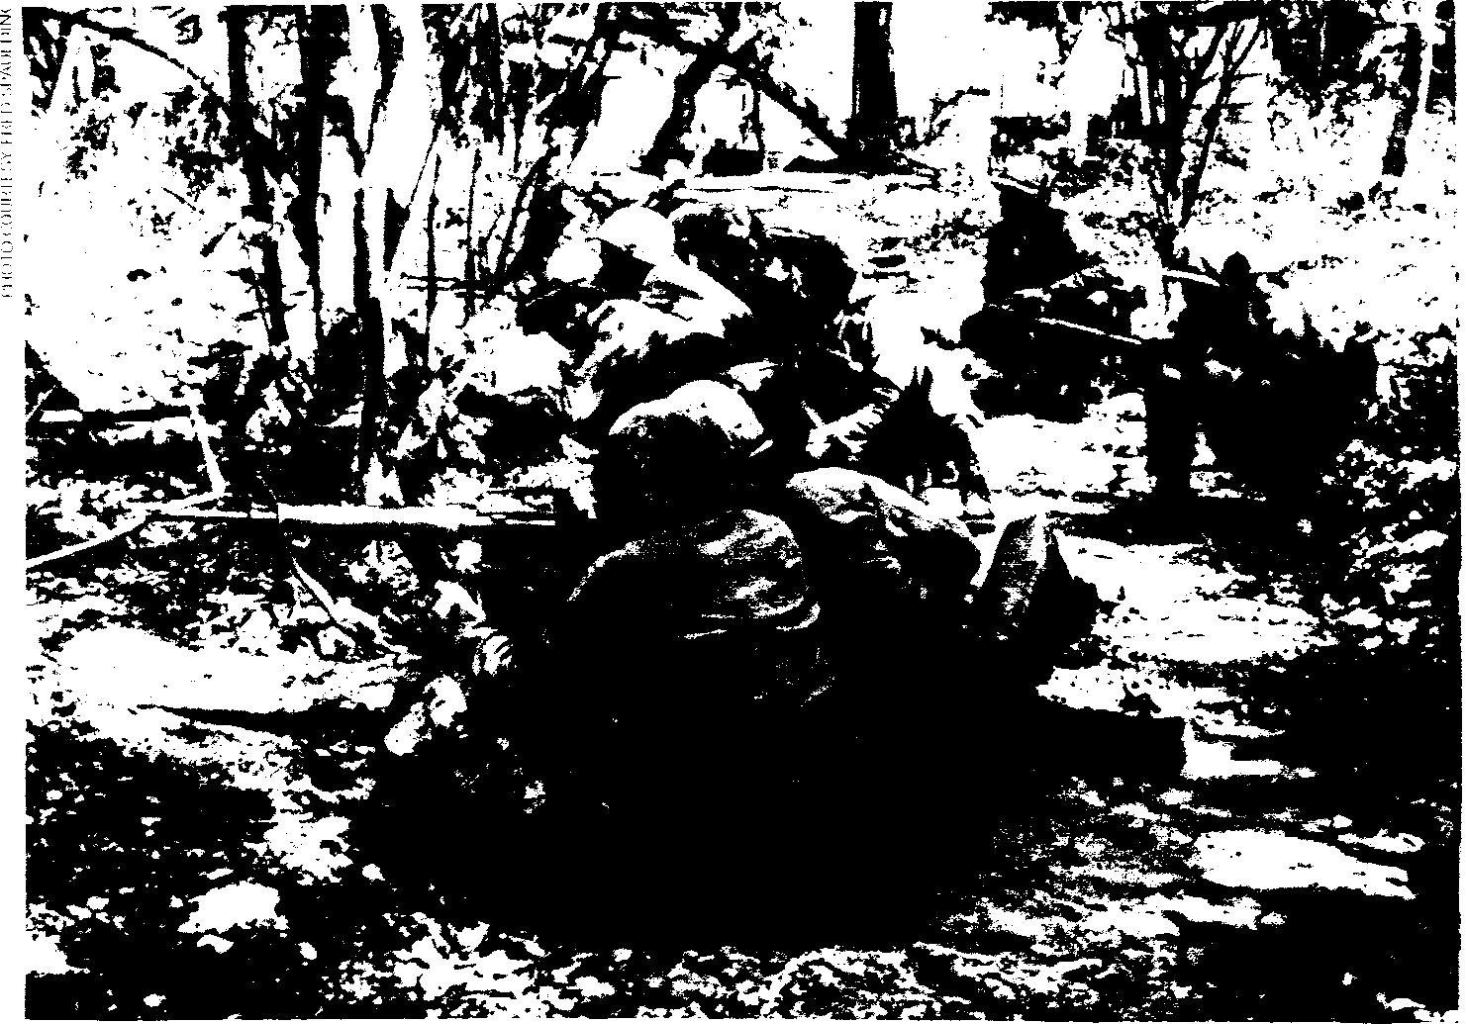
off, kiiiing 5. and 4 ground crewmen.
1979 Apr 12 Turkey. Izmir. 1 U.S. airman is killed by Turkish
Marxist terrorists.
May 11 Turkey. Istanbul. 1 GI is killed by Turkish Marxist terrorists.
May 15 Arabian Sea. Planes from the USS Midway take to the sky when 2 Soviet IL-38s circle the carrier. Dec 14 Turkey Istanbul. 1 GI and 3 civilians are killed by Turkish Marxist terrorists.
1980 Apr 16 Turkey. Istanbul. 1 U.S sailor is killed by Turkish
Marxist terrorists.
Nov 15 Turkey Adana. Incirlik AB. 1 U.S. airman is killed by Turkish Marxist terrorists.
Dec 10 Germany. Soviet Union threatens to invade Poland. U.S. deploys four E-3A planes.
1981 Aug 31 Germany Ramstein. Marxist RAF bombs Air
Force HQ: 17 WIA.
1983 Nov Germany During NATO's exercise Able Archer,
Warsaw Pact units go on full alert, believing the West is about to launch a pre-emptive nuclear strike.
Nov 17 Greece. Athens. 1 U.S Navy officer is killed by Greek Marxist terrorists.
1985 Mar 24 GERMANY. Last U.S. Hostile Death Due to
Soviets. Maj. Arthur D. Nicholson, jr., part of the U.S. Military Liaison Mission in East Germany, is shot dead by a Soviet sentry in Ludwigslust. Nicholson is posthumously awarded the Legion of Merit & Purple Heart. Aug 8 Germany, Rhein-Main AB. Marxist RAF car bomb explodes' 1 U.S. KIA, 17 WIA. 1 GI is also killed by the RAF in Wiesbaden.
1987 Jan 25 Mediterranean Sea. An EA-3B (Ranger 12) of
VQ-2 crashes off the flight deck of the USS Nimitz, killing 7 crewmen. This is the last of the Navy's Cold War fatalities in aerial electronic reconnaissance.
1988 Jun 28 Greece. Athens. U.S. defense attaché is killed
by Greek Marxist terrorists.
1989 Nov 9 Germany. Berlin. Wall Falls. B Co., 6th Bn.,
502nd IR, is the U.S. infantry unit on duty at the time. Signals effective end of Cold War in East Europe.
1990 Mar 1 Germany. Fulda Gap. Last Patrol. llth ACR
conducts the final border patrols of Cold War in Europe.
1991 Mar 12 Greece. Athens. 1 U.S. airman is killed by a
Greek Marxist terrorist bomb.
Dec 25 Soviet Union. Moscow. Soviet Communism Collapses. USSR ceases to exist.

UNDERWATER STEALTH: The USS Tautog was rammed by a Soviet sub while shadowing it in June 1970. In all, 217 crew members and 18 civilians from three subs were lost during the Cold War. At least 16 submariners died in other accidents.
A VIGILANT WATCH: Marines with bayoneted rifles man a sandbagged position, keeping watch along the perimeter of Guantanamo Bay Naval Station, Cuba, on Nov. 14, 1962.  VFW HIT PHOTO | NORTHERN OUTPOST: Men of B Battery, 549th Anti-Aircraft Artillery Battalion, performing base defense at Thule Air Base, Greenland, in 1954.

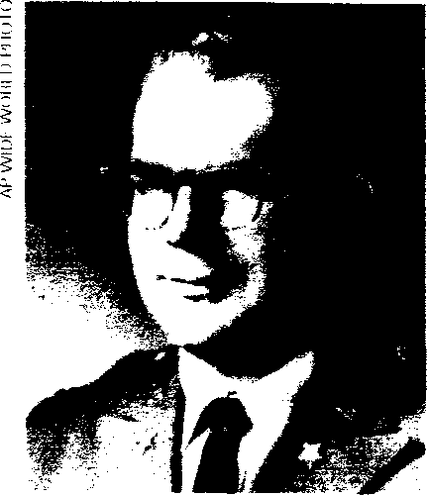
KIA: Col. John D. Webber, Jr., was assassinated by Guatemalan Marxist terrorists in Guatemala City on
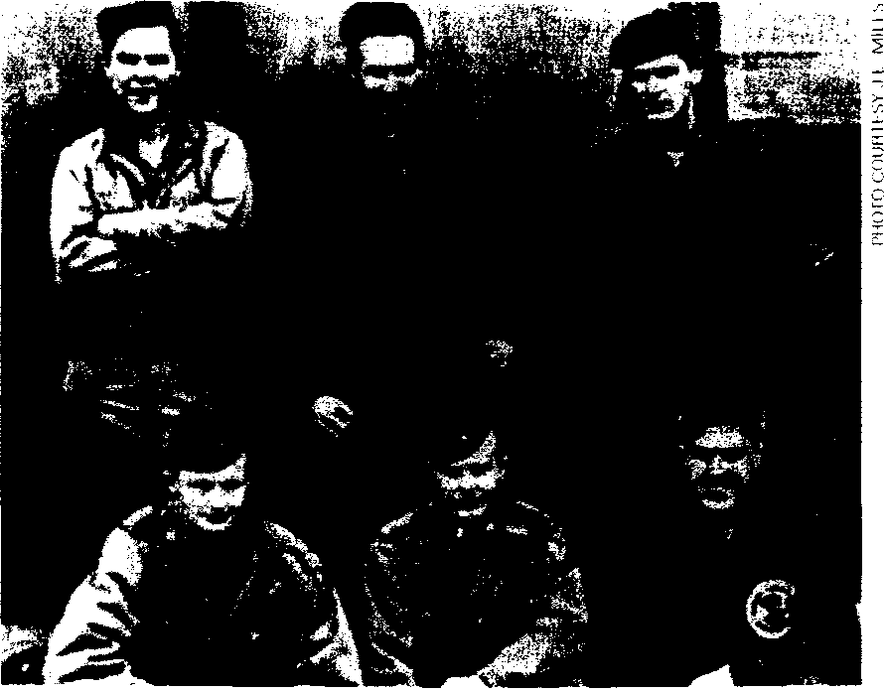
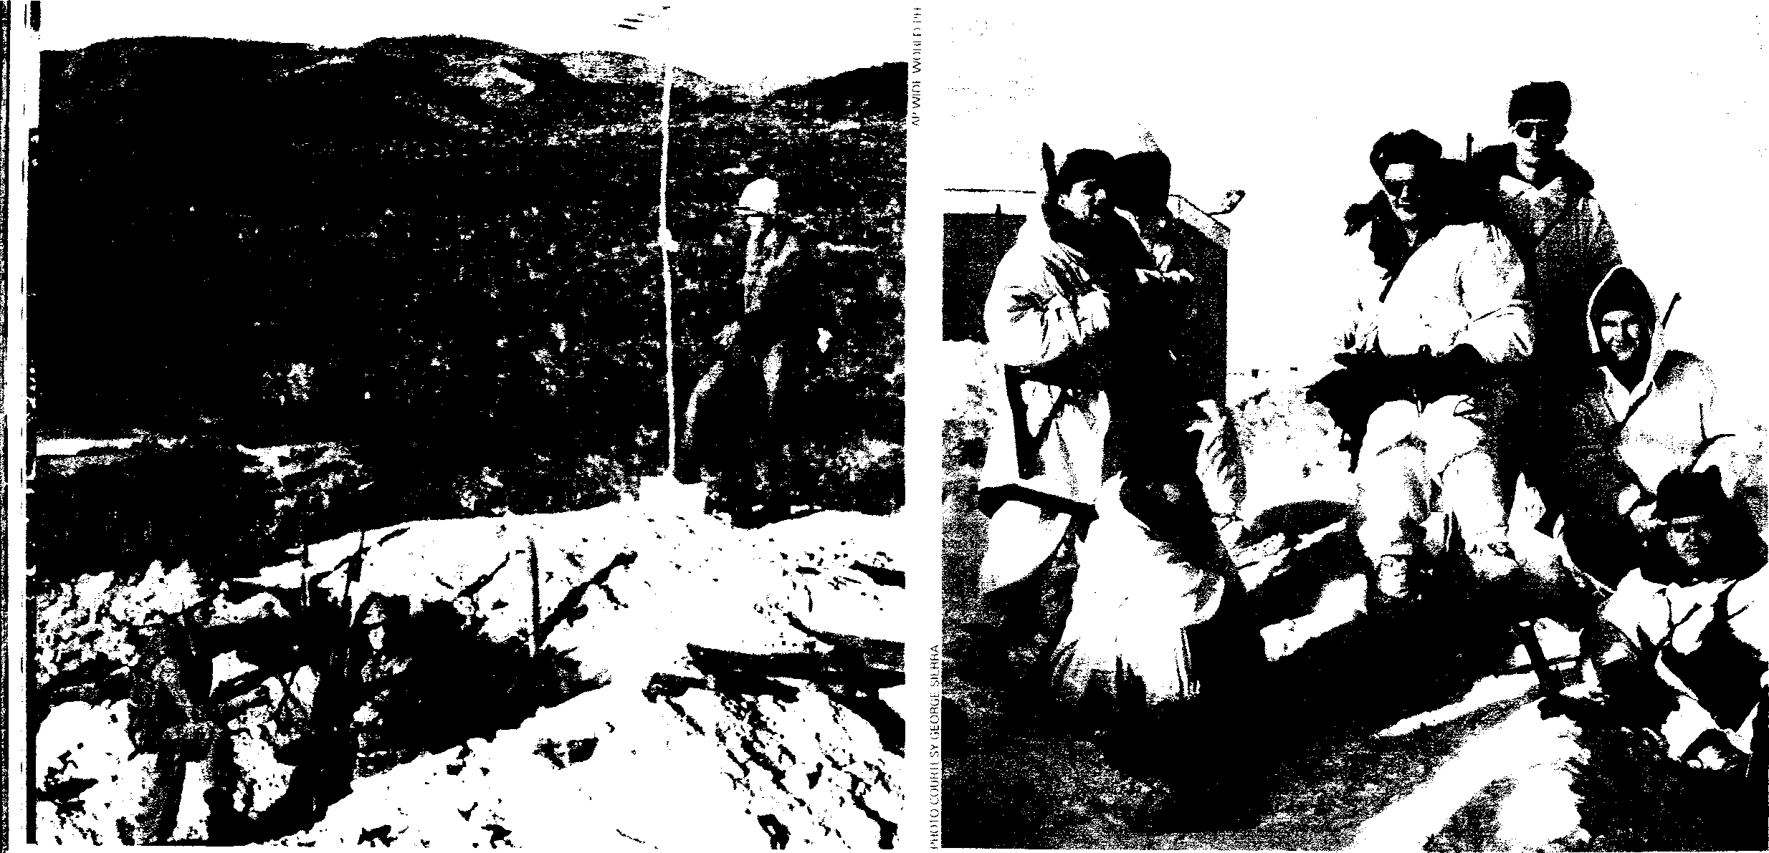
Jan. 16, 1968.
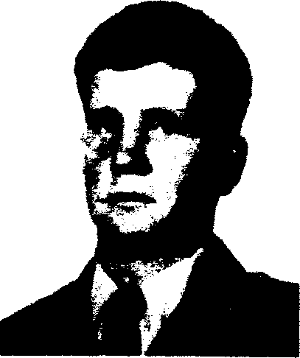
KIA: Special Forces Staff Sgt. Gregory Fronius was killed in action fighting Marxist guerrillas in El Salvador in 1987.
1966 Sep 21 Dominican Republic. Last U.S. troops depart.
Total U.S. Casualties: 27 KIA, 172 WIA. Non-hostile deaths: 20.
1968 Jan 16 Guatemala. Guatemala City. 2 U.S. military
advisers KIA & 2 WIA by Marxist terrorists.
Oct 12 Brazil. Sao Paulo. 1 U.S. Army officer is assassinated by Marxist terrorists.
1979 Dec 2 Puerto Rico. San Juan. 2 U.S. sailors are killed by
Macheteros (Marxist terrorists).
1981 Jan 1 El Salvador. U.S advisers begin training
Salvadoran armed forces to combat Marxist guerrillas. 1982 May 16 Puerto Rico. San Juan. 1 sailor from USS
Pensacola is killed by Marxist terrorists.
1983 Oct 23-Nov 2 Grenada. Operation Urgent Fury is
designed to counter Marxist government. 20,000 U.S troops participate. U.S.: 10 KIA, 120 WIA + 9 non-hostile deaths. Cubans: 24 KIA, 59 WIA. Grenadians: 21 KIA, 337 WIA.
Oct 25 Grenada. Ambush at Calliste. Gun Jeep Team Five, A Co., 1st Bn., 75th Rangers, is ambushed by Marxist Grenadian soldiers. U.S.: 4 KIA.
May 25 El Salvador 1 U.S. Navy SEAL is assassinated by FMLN (Marxist terrorists).
1984 Jan 11 Honduras. 1 U.S. Army helicopter pilot is KIA by
Sandinistas near Nicaraguan border.
Oct 18 El Salvador. CIA plane crashes: 4 agents die. 1985 Jun 19 El Salvador 4 unarmed U.S. Marines are
murdered by FMLN guerrillas while off duty.
1987 Mar 31 El Salvador El Paraiso. 1 Special Forces soldier
is KIA in a firefight with FMLN.
Jul 15 El Salvador 6 GIs die in a helicopter crash while evacuating an injured Gl.
1991 Jan 2 Honduras. Rafael Habra. FMLN shoots down a
U.S. helicopter of the 4th Bn., 228th Avn. Regt.: 3 KIA. Feb 25 El Salvador. Lake llopango. U.S. helicopter crashes: 5 GIs die.
1992 Feb 1 El Salvador. Last U.S. advisers (3,600 served
there during insurgency) depart. Total U.S. Casualties: 10 hostile deaths, 26 WIA. 10 non-hostile deaths.
Ice Curtain
ARCTIC BORDERLANDS
1942-45 Siberia. WWII. Soviet anti-aircraft downs U.S. planes;
others crash-land on the Kamchatka Peninsula attempting to find sanctuary. 291 American aviators are held as POWs in a Soviet prison camp at Vrevskaya, Uzbekistan. Some Americans are KIA in shoot-downs; 8 others die in camp from injuries or disease.
1945 Sep 4 Kurile Islands. North Pacific. 15 Soviet fighters
trail 2 U.S. B-24s of the 404th BS, 28th BG, 11th AF, that are on a photo recon mission.
1946 Jun Alaska. Fairbanks. Ladd AFB. SAC's 46th Bacon
Squadron (later 72nd) begins flying recon missions along the Soviet Arctic rim.
1947 Feb 24 Bering Sea. B-29 of the 28th BS disappears: 12
crewmen die.
COLD WAR POWs: 291 airmen were interned by the Soviet Union during WWII after crash-landing or being shot down over Siberia. They were released in 1945. Back row (left to right4: William Crowell, John Carr and Warren Lawton. Front row: Ralph Hammond, William Head and John McIntosh.

164 Cold War Clashes • VFW © 2004

1949 Aug 24 Greenland Sea. Off Norway. USS Cochino, on
OPERATION DRAGON ROUGE by A. Michael Leahy. On Nov. 24, 1964, U.S. C-130 crews plunged into the Congo bloodbath to rescue Europeans and Americans held hostage by Marxist-led rebel "Simbas."
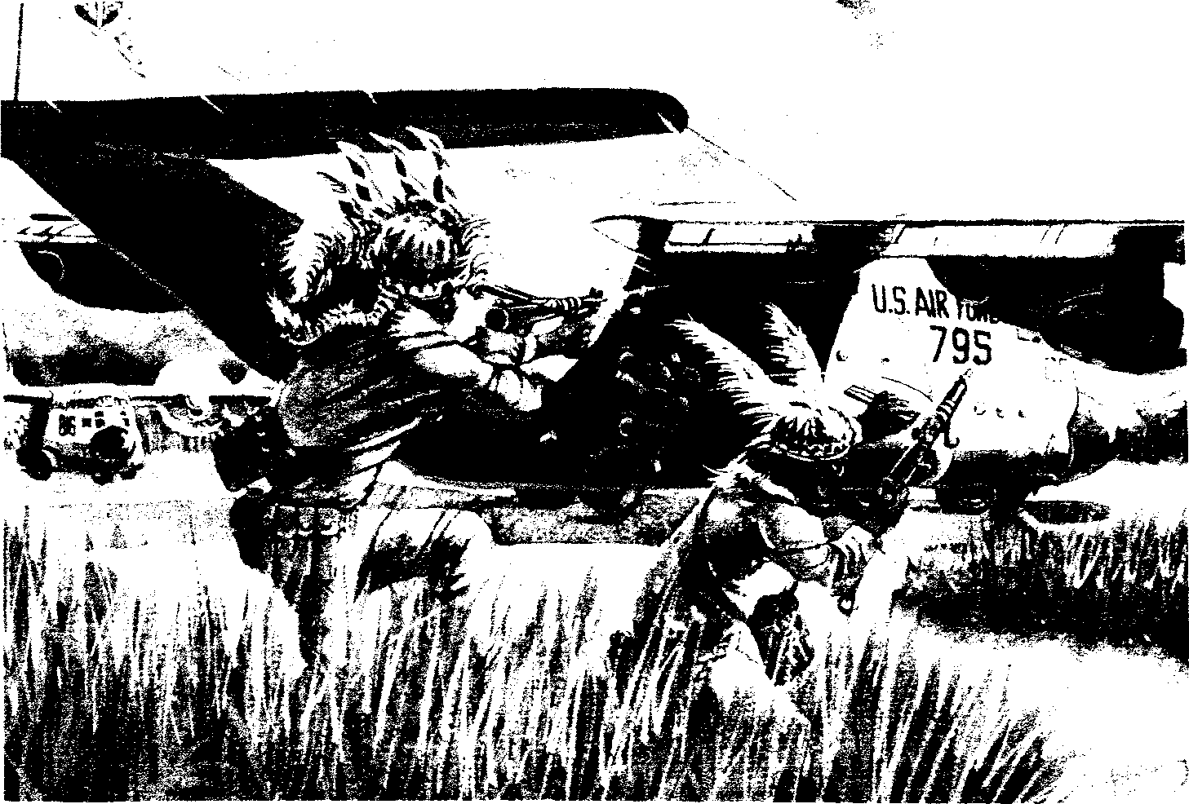
a recon mission, sinks after a battery explosion. 1 man dies. USS Tusk, while offering aid, loses 6 men.
1952 Oct 15 Siberia. Alaska. Fairbanks. Eielson AFB. SAC
launches Project 52 AFR-18. Two modified B-478 bombers overfly the Chukotskiy Peninsula, taking photos of Soviet staging bases.
1953 May 15 Siberia. Off Kamchatka Peninsula. Soviet MiG-
15 opens fire on a SAC WB-29 recon plane. U.S. gunners return fire. No casualties.
1955 Apr 17 Siberia. Off Kamchatka in Bering Sea. 2 Soviet
MiGs shoot down an RB-47E of the 4th SRS, 26th RW (based at Eielson AFB): 3 KIA.
Jun 22 Alaska. Bering Strait. 2 MiG-15s shoot down a P-2V Neptune (VP-9): 3 WIA. 4 men are burned when it crash-lands on St. Lawrence Island.
1956 Mar 21-May 10 Greenland. Thule Air Base. Project
Homerun. 10th and 343rd SRS fly 156 overflight
missions along the Soviet rim with no losses.
1959 Feb 26 North Atlantic. Off Canada. Sailors from the
USS Roy 0. Hale board a suspected Soviet spy trawler to investigate reports of tampering with transatlantic cables.
1960 July 1 Barents Sea. Soviet Kola Peninsula (30 miles
north of Kola). Soviet fighter shoots down a U.S. RB-47 (55th SRW): 4 KIA + 2 POW for 208 days in Moscow's Lubyanka Prison.
1961-1991 Alaska. U.S. pilots intercept 307 Soviet intruders in Alaskan airspace.
1964 Nov 23-27 Congo. Operations Dragon Rouge/
Dragon Noir. 12 C-130s from the 322nd Air Division (based in France) & the 464th TCW help rescue Europeans and Americans threatened by Marxist-led "Simba" rebels. GIs from the 504th IR, 82nd AD, and 23rd IR, 2nd ID, provide security on the ground.
1967 Jul-Aug Congo. Operation Bonny Birch. 3 C-130
crews of the 464th TCW airlift Congolese troops during a rebellion.150 men of a special U.S. task force also participate.
1971 Jan 11 Ethiopia. Asmara. 1 GI is killed by Eritrean
terrorists. U.S. maintains a communications station at
Kagnew, which monitors Soviet radio traffic.
1975 -76 Angola. Operation Feature. CIA launches to counter Soviet-Cuban intervention in southwest Africa. CIA personnel and an Army mobile training team reportedly operate inside Angola. 7 U.S. volunteers participate in fighting: 1 KIA, 3 POW (1 executed).
1978 May 16-Jun 18 Congo. Cuban- and Soviet-supported
guerrillas from Angola invade Saba (formerly Katanga) Province, killing 200 foreigners. Elements of numerous U.S. Air Force airlift units help transport supplies and equipment as part of the French-Belgian rescue of 3,080 foreigners.
1984 Apr 15 Namibia. Oshakati. 1 U.S. Army attaché and a
U.S. diplomat are killed by a Soviet-made mine planted by Marxist guerrillas known as SWAPO.
1989 Nov 27 Angola. Jamba. CIA plane crashes, killing 3
Americans. CIA was supporting anti-Communists.
1962 Jan 12 Greenland. Wiedemannsfjord. Kronborg
Glacier. P-2V Neptune (VP-5) on an ice recon mission crashes: 12 men die.
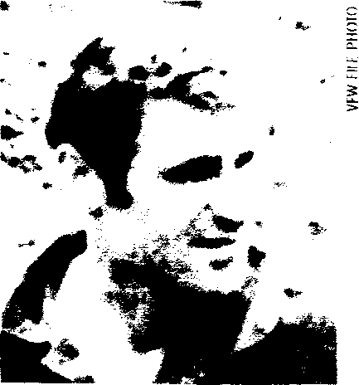
KIA: George Bacon III, ex-Green Beret and
former CIA operative, was killed in action in a Cuban ambush in Angola on Feb. 14, 1976.
1962-1991 Iceland. U.S. 57th Fighter-Interceptor Sqdn. intercepts 3,000 Soviet aircraft intrusions into Icelandic airspace: more than all other USAF units combined worldwide.
1968 May 25 Norwegian Sea. 200 mi. off Norway. 2 Soviet
TU-Badgers harass the USS Essex. 1 Russian aircraft loses power, crashing into the sea: All 6 crewmen die.
1969 Jan 13 Aleutians. Shemya. RC-135 (6th SW) crashes. Jun 5 Bering Sea. RC-135 (55th SRW) crashes (cause unknown): 19 airmen die.
Oct-Nov Barents Sea. USS Lapon tails a Soviet sub for 40 days.
1972 Dec 19 Barents Sea. Soviet YAKs intercept an RC-136,
but mistakenly fire on their own nearby navy Badgers. 1979-86 Barents Sea. USS Parche completes numerous recon
missions and is highly decorated.
1981 Mar 17 Aleutians. Shemya. RC-135 (6th SW) crashes: 6
crewmen die.
1984 Jan North Pacific. U.S. Third Fleet faces off against the
Soviet Pacific Fleet.
1985 Feb 25 Alaska. Valdez. RC-13516th SW) crashes: 3
crewmen die.
Jungle Curtain
SUB-SAHARAN AFRICA
1960 Jun-Jul Congo. Independence from Belgium prompts

Cold War: U.S. Hostile Deaths
American military personnel and civilian operatives
killed as a result of enemy action: Listed by adversary.
Enemy U.S. Killed
Communist Terrorists/Guerrillas 107
Soviets 105
North Koreans 92
Chinese 55
Others (Yugoslays, Cubans, Grenadians) 23
TOTAL U.S. KIA: 382
NOTE: These figures do not include the thousands of GIs killed by the Chinese in the Korean War t1950-53) or the hundreds of airmen killed by the Soviets in aerial duels during that war
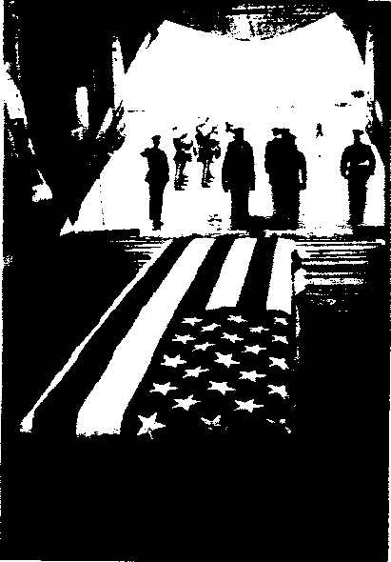
Communist-led rebellion. U.S. Army helicopter crews receive heavy fire from Congolese rebels during rescues. Aug 27 Congo. Stanleyville. Congolese rebels attack a C-124 crew of the 20th ATS: 4 WIA. Operation New Tape airlifts U.N. troops in the wake of a failed Communist coup. Missions continue until September 1962.
? Sudan. Khartoum. U-2 (WRSP-2) crashes.
1964-65 Congo. U.S. Joint Task Force Leo (126 Americans)
assists the government in the face of a Chinese Communist-backed revolt. On Sept. 7, 1964, the Congolese rebel leader declares war on the U.S. Some Leo airmen fly combat support missions. U.S Air Force RC-97s fly recon missions under Operation Running Bear CIA operative shot down July 26, 1964, while flying combat mission and dies of wounds

WPM on Anna • rnIri
1PP

