# 3.5" Touchscreen Multimedia Player - $49.99

# There are a lot of touchscreens like the 3.5" Large Screen - Pyrus Electronics 4gb 3.5" Touch Screen Mp3/mp4/mp5 Personal Multimedia Player. It costs $49.99 but is too small for us.

# 6.5" Touchscreen DVD Player - $169.91 The New! 6.5 2 Din Car dvd + TV + Radio + bluetooth + touch screen costs $169.91. Still too small I think.

**22" Touchscreen Monitor - $399.99   
Dell Tower Computer for Monitor - $599.99**This Planar PX2230MW 22" Class Widescreen Multi-Touch Monitor - 1080p, 1920x1080, 16:9, 1000:1 Native, 5ms, VGA, DVI, would require a computer.

The Dell - Inspiron Desktop / Intel® Core™ i3 Processor / 6GB Memory / 750GB Hard Drive is a tower computer that costs $599.99 at BestBuy. Something like this would have to be attached to this monitor.

**19" TV without dvd player - $141.44**The[Coby TFTV1925 19-Inch Widescreen TFT LCD 720p HDTV/Monitor with HDMI Input (Black)](http://www.amazon.com/Coby-TFTV1925-19-Inch-Widescreen-Monitor/dp/B0037KLEKA/ref=sr_1_8?ie=UTF8&qid=1290267922&sr=8-8) by Coby costs $141.44. **This would not be touchless.**

**19" TV with DVD Player - $179.00**The [Coby TFDVD1995 19-Inch 720p Widescreen LCD HDTV/Monitor with DVD Player and HDMI Input (Black)](http://www.amazon.com/Coby-TFDVD1995-19-Inch-Widescreen-Monitor/dp/B00381YRAW/ref=sr_1_1?ie=UTF8&qid=1290268155&sr=8-1) by Coby costs $$186.00. **This would not be touchless.**

**17" Laptop Touchscreen Computer - $1,375.00**The HP Pavilion dv6t Select Edition - Windows 7 Home Premium, Intel Core i5-450M Dual Core processor 2.40GHz, 6GB DDR3 Ram, 640GB HD, 512MB ATI Mobility Radeon HD 5470, Blu-ray +/-R/RW with SuperMulti DVD+/-R/RW, 15.6" diagonal High Definition LED HP Widescreen with TouchScreen and HP TouchSmart's intuitive multi-touch applications, Webcam, Intel Wireless-N Card with Bluetooth costs $1,375.00.

# It looks to be about the size of a standard laptop or notebook computer. It has been upgraded to blu-ray which I believe is one generation higher that a dvd. It would require us to build some sort of computer mount.

**Notebook Computer Mount**

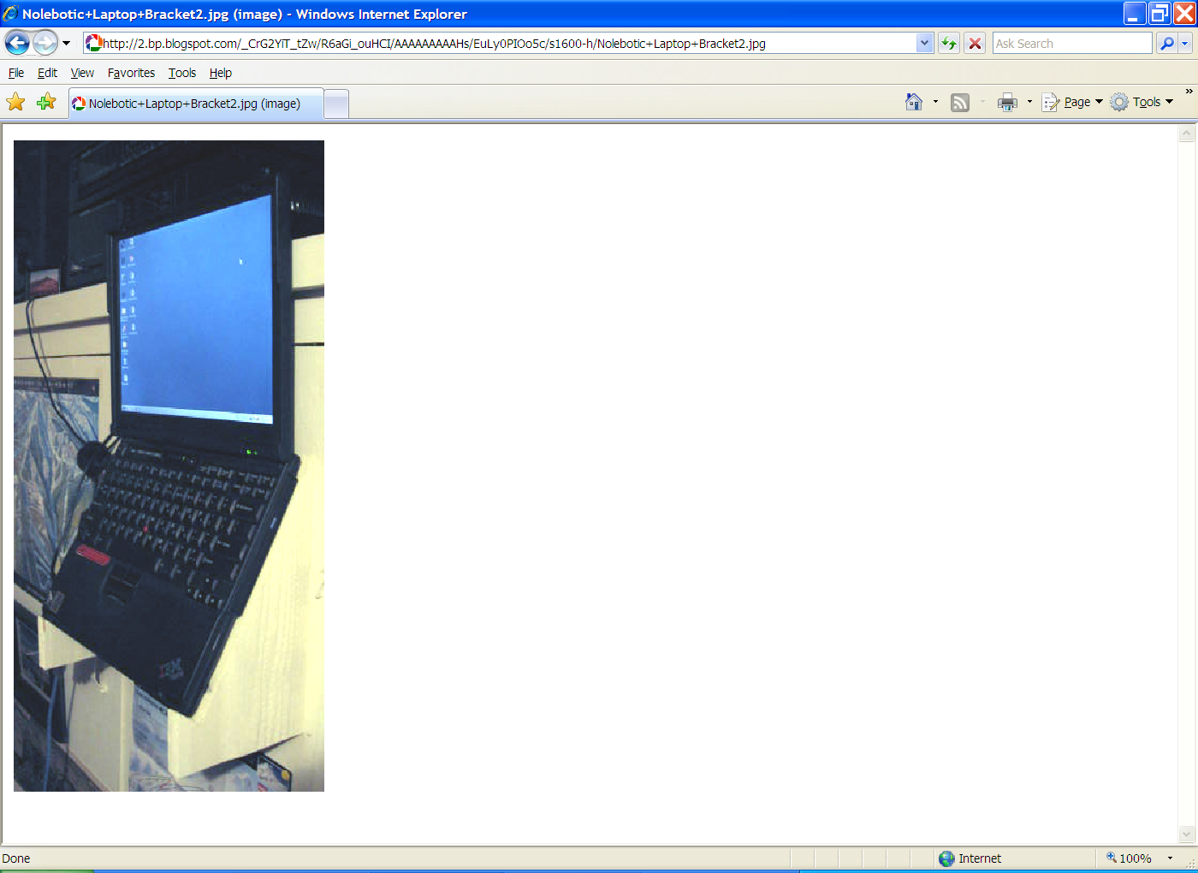

For a touchscreen notebook computer, we could build something like this out of plywood, and

* Completely hide the lower keyboard/computer behind plywood
* Make the lower keyboard/computer completely vertical since there would be no typing allowed on it.
* Secure the monitor in the upright position with some sort of a locking device.

**24" Touchscreen TV/Computer - $1,300.00**

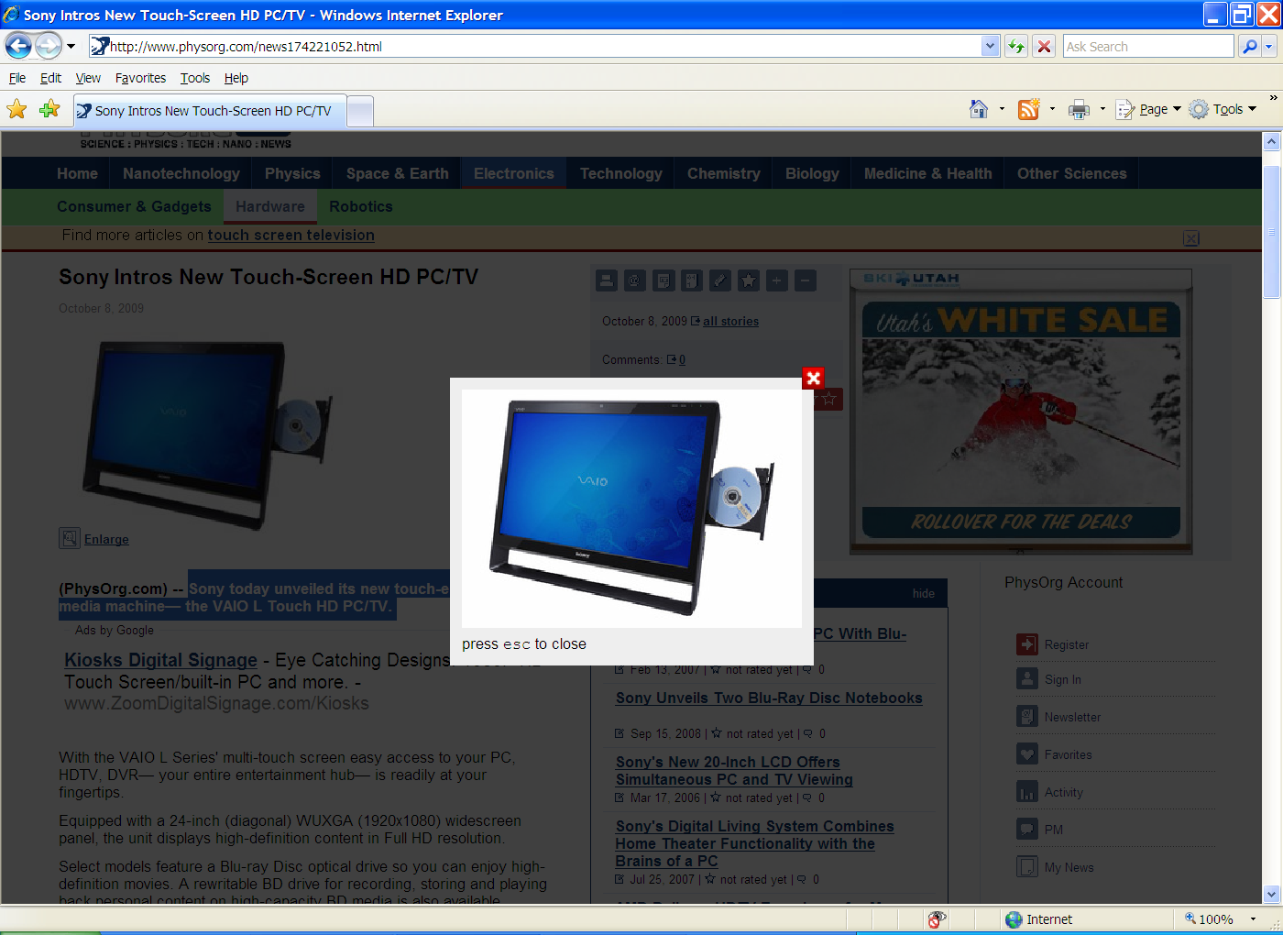

**This one has a wireless keyboard that could be removed from the display area.**

**Sony today unveiled its new touch-enabled, multimedia machine— the VAIO L Touch HD PC/TV.**

Select models feature a built-in tuner so you can **connect to your** [**digital cable TV**](http://www.physorg.com/tags/digital+cable+tv/) **service and Over-The-Air (ATSC) HD TV signals (antenna required) and watch television on your PC.** This might be attractive for museum volunteer receptionists this summer.

An optional HDMI input is available, so in addition to the unit’s built-in HD features you can connect a compatible HD cable box, satellite receiver or [PLAYSTATION 3](http://www.physorg.com/tags/playstation+3/) via a single cable and enjoy HD entertainment without powering on the PC.

And with built-in DVR capabilities and up to a terabyte of storage, you can create a personal entertainment library with up to 100 hours of HD television.

It comes with Windows 7 Home Premium or Professional 64-bit operating system. Leveraging these new operating systems, the L Series is able to offer new functionalities such as a touch screen display enabling you to do anything you could do with a mouse with the touch of a finger.

Launch directly into Sony’s own Media Gallery software by pushing the designated VAIO button on the keyboard and create high-quality home movies and slideshows in three simple steps. Import your photos and video, choose a theme and soundtrack, click finish and the software does the rest, generating a professional-looking movie complete with special effects— **all by touching the screen**.

The unit packs a powerful Intel Core 2 Quad processor (select models), loads of RAM, and a dedicated [NVIDIA GeForce](http://www.physorg.com/news174221052.html) series graphics for graphic-intense gaming and movies.

By utilizing built-in wireless 802.11 b/g/n Wi-Fi technology and your wireless router (required, sold separately), you can position the model virtually anywhere in your home and access the Internet, email or home network.

The model is ideal for anywhere space is at a premium. It has a mounting capability that allows users to attach a VESA-compatible mount (sold separately) to it and **hang it on the wall of your bedroom, kitchen**, [office](http://www.physorg.com/news174221052.html) or attach to your desk.

When not mounted to the wall, the L Series features an adjustable stand to help you adjust the unit to meet your desired viewing or touch angle or simply to decrease the slant for space-saving. A wireless keyboard, mouse and remote control (select models) are included.

The VAIO L Touch HD PC/TV will start at about $1,300. It is available for pre-orders today online at sonystyle.com/pr/l

# The price would probably be higher after we add all the options for the "select models".