## Tag: Museum Kiosk

## [Using Adobe Flash/AIR for Museum Touch Screen Kiosk Application Development](http://backroom.bostonproductions.com/?p=416)

by [Bruce](http://backroom.bostonproductions.com/?author=2) on Nov.20, 2009, under [Hardware](http://backroom.bostonproductions.com/?cat=29), [Software](http://backroom.bostonproductions.com/?cat=14)

If you’ve never developed a touch screen application before, there’s a lot to think about that makes it different from a browser based or native application. It’s impossible to go through the full breadth of things to consider, but I figured posting a few helpful tips might be good.

**Well Spaced and Big Button Sensing Areas**So, this does not necessarily mean giant buttons. Often that’s a good solution, since museum visitors are not just those familiar with computers but include many folks who don’t interact daily with computers. Really though, it’s about making sure that the sensing areas of buttons are forgiving enough to work with clumsy fingers, and to account for the different alignment people will get from looking at the screen from different angles. If you touch a screen from a low angle on what you see as the button area, and then change your perspective, that button area can be drastically different from above. A mouse is absolute. The button is the button. But with a fingers on a large screen, it can actually change. So, large sensing areas for the buttons, and don’t put them too close together to account for different perspectives and clumsy fingers.

**Consider Hand Position**When using a touch screen, a person uses their hand, thus creating a natural block for some of the screen area. With a mouse pointer, it’s small enough that unless an interface is very tiny, it won’t block anything when using it to select menu items, etc. But, with a finger, you’ve got a whole hand attached. So, imagine you have a screen where you have 5 buttons. Each button makes a change to a large image in the center of the screen. Although many web pages have navigation and other items at the top, this makes little sense in our scenario, because you want to see how your selection is changing the screen. If the buttons are at the top, you’ll have to move your hand away each time you press one to see the results. It may make more sense to place buttons along the bottom, or the right side. Although it may seem biased, you have to consider that most people are right handed, and if you have to favor one or the other, then choose right. The main thing to get from this one is just to think about where people’s hands are going to be and if they’ll be blocking items you need them to see when operating the screen.

**Choose the Best Viewing Angle**This has more to do with fabrication than the software programming. You should make sure you consider who the audience is when choosing what angle and height to put the screen at. It seems like a basic enough idea, but there are many times when we haven’t been involved in the hardware or installation decisions of an institution, and they’ve installed a touch screen for children flat on a table that’s 36 inches high. How can a kid see that properly without standing on something? Or, a kiosk is supposed to take a photo of a person to put on postcard and email home, yet the camera is pointing almost at the floor, so if you’re over 3 feet tall, you’re bending awkwardly and contorting to get in the picture. Little things like this really affect the usability of a screen.

**Hide the Mouse**  
I really don’t understand museum exhibits that have mice showing. I think people leave it there so that you see where you’re clicking and navigating. The thing is, you don’t want people to walk up to a touchscreen and see it as just a computer program running. You want them to walk up and see it as an experience that is something they can’t get at home. You can click on buttons at home, but you can’t touch a screen and move elements around the same way you can on a touch screen. Having the mouse pointer on screen breaks up your interface and reminds people they’re just looking at a computer screen.

**Give Clear Direction**An interface must give users clear direction about what to do. Children will walk up to an exhibit and start banging away on the screen and they’ll figure it out. It’s the visitors that are new to touch screens and computer interactive programs that will just stand and stare at the screen, not sure what to do next. Things need to be clearly defined, and text must be readable. Sure, many people won’t read the directions, no matter how much you highlight them, but they need to be able to understand what to do by visual clues. There is a lot that can be written about creating touch screen interfaces, but my overall comment here is make sure people understand what to do.

I’m open to suggestions here, and I am not saying my comments are the be-all and end-all, but we’ve certainly learned a lot from working in this area for years. Some other miscellaneous items to consider:

- There are no rollOver or rollOut commands. Tooltips, highlights, etc. won’t work since it’s just about single touches.  
- It’s good to use high contrast colors to make sure it’s visible to as many people as possible  
- Choose a [type of touch screen technology](http://backroom.bostonproductions.com/?p=227) that works for what you need. (Capacitive, Resistive, SAW, etc.)

Anyone else have any tips?

## [Types of Touch Screen Technologies for Museum and Visitor Center Kiosks](http://backroom.bostonproductions.com/?p=227)

by [Charles](http://backroom.bostonproductions.com/?author=3) on Nov.13, 2009, under [Hardware](http://backroom.bostonproductions.com/?cat=29)

One of the major components of many interactive exhibits is a touch screen.  We routinely work with a variety of touch screen types and technologies at Boston Productions.  Without firsthand experience it is difficult to know which technology works best for a given situation.  The process of purchasing and implementing a screen that will be used by thousands of people a day is also a bit of a mystery unless you have done it before.  You’re in luck because I am going to provide a firsthand overview of each technology I have worked with and common mistakes made while implementing them.

**About Purchasing Touch Screens**

Usually the big monitor manufacturers such as NEC and Samsung don’t actually make touch aware systems.  When purchasing touch monitors you usually buy them from a company that purchases a monitor and modifies it by adding touch capability after the fact.  This adds to the complexity of purchasing because you need to make sure that you are initially getting a good monitor, but are also working with a competent touch screen integrator.

**The Types of Touch Systems**

[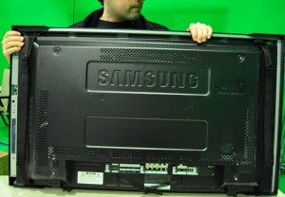](http://backroom.bostonproductions.com/wp-content/uploads/2009/07/iroverlay1.jpg)

Charles Holding a Nextwindow IR Overlay

**Capacitive** – Capacitive touch screens work by sensing small changes in the electrical pattern over the touch screen surface. Your skin creates small electrical connections, and the touch screen software can interpret these to know exactly where your finger is located. Skin, or another conductive material is needed to make capacitive screens work properly. Using a stylus or other pointing device will not work. For instance, the iPhone touch screen is a capacitive screen.

**Resistive** - Resistive touch screen work by sensing any pressure by any object. It contains a couple layers of sensors and materials. There is a thin layer of a similar material that is the main part of the capacitive screen. It will detect small connections made when contacted by a conductive material. In this screen though, there is another layer of this conductive material that is very thinly separated from the capacitive layer. By touching the screen, you’re pressing down to create contact between the layers, and registering a touch with the computer. Many devices that use a stylus are resistive screens like the bottom screen of a Nintendo DS, or Palm handheld devices.

**SAW** – Surface acoustic wave is based on sound waves traveling across the surface of the touch screen.  When they are disrupted, the sensors know where you have touched.  For the programmer, a SAW screen can emulate a mouse just like you would expect it to. The SAW technology is what we prefer and use on most of our systems.

**Infrared** – Infrared is usually based on IR LED’s close to the surface of the screen coupled with cameras that can detect where the IR beams are being disrupted.  You normally can purchase an IR overlay as a completely separate piece of equipment from your monitor and install it on site. These are commonly used on larger screens where other technologies become less accurate. For instance, making a capacitive screen that is 40 inches is very difficult, so often an IR overlay is used. Often, this detects when a finger or other object breaks the plane of the IR beans, so you can sometimes operate an IR screen without actually ever touching the screen.

**DST** – Dispersive signal technology is based on sensing changes in the mechanical energy happening on the surface of the screen.  You can touch the screen and it will recognize it as a click, but if you continue to hold your finger down, without moving, this type of overlay will think you are no longer touching it.  
An advantage of this technology is you can have items already sitting on it, and if they remain stationary; touch functionality will be unaffected for the rest of the screen.  This situation works best for touch screens that are integrated into work surfaces that you could benefit from allowing stationary items to rest on the screen.  
Remember that with this technology it is not possible to accurately or consistently touch and hold items while remaining stationary.

**Implementation**

Although they may seem very similar, each type of technology requires different care and consideration when implementing.

General Considerations

[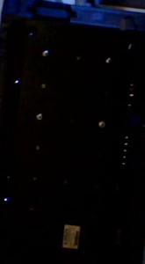](http://backroom.bostonproductions.com/wp-content/uploads/2009/07/dst_impropermount.jpg)

See how the mounts are not even across the monitor? This is a DST mount that is likely to have issues.

Proper ventilation is always needed when using touch screens.  You will often find that when a monitor overheats you lose touch intermittently or altogether.  This usually means purchasing 80mm fans and installing them in your monitor enclosure.

Be very careful with the bezels of monitors and area directly around the touch surface.  We routinely work with fabricators that love to cover up the bezels of a touch monitor.  When this happens it’s imperative that these covers are not putting pressure on the bezel of a touch screen, or are physically contacting the touch surface.  When this happens you normally end up with a non functioning touch screen.

If covering the IR sensor for a monitors’ remote, have the fabricator drill a small hole so your remote does not become useless.  It’s always handy to be able to use the remote even with a touch screen.

Technology Specific Considerations

DST – In my experience with DST, I worked on several large monitors that were to be mounted vertically.  Due to the way that DST works, you have to be extremely careful when mounting

[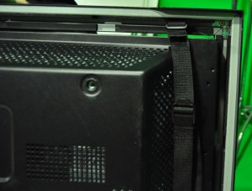](http://backroom.bostonproductions.com/wp-content/uploads/2009/07/iroverlay2.jpg)

The Gap Between the Monitor and Overlay is Not Acceptable

the monitor not to put any pressure on the screen or bezel.  Because it works based on mechanical energy, if you apply pressure from your mount on one area of the screen more then another, your touch overlay will become biased in one direction.  The result of this biasing is that you have a touch overlay that is more sensitive in one area then the other, or completely unusable.

SAW – Just make sure that you don’t have anything else touching the overlay when you implement it.  Also make sure to clean the monitor surface semi-regularly.

Infrared – With infrared, just make sure you don’t have debris blocking any portion of the IR LEDs or their associated cameras’.  An example of a debris that is pretty common is packing material.  If using an external overlay that you strap to the monitor, make sure that the overlay is very snug against the side edges of the monitor so that it will not move when mounted.  Many external IR overlays can conceptually be imagined as a picture frame.

This is meant as a brief overview of touchscreen technology, and a starting point when trying to determine which type of screen is right for you.

## [How to Setup Windows Vista as a Museum Kiosk](http://backroom.bostonproductions.com/?p=343)

by [Charles](http://backroom.bostonproductions.com/?author=3) on Sep.16, 2009, under [Hardware](http://backroom.bostonproductions.com/?cat=29), [Software](http://backroom.bostonproductions.com/?cat=14)

If you want to setup Windows Vista to work in a museum environment, you are not faced with an easy task. Vista provides more automated features for novice users than any other Microsoft operating system. In a kiosk mode, we want all these features off so they don’t interfere with the exhibit or cause maintenance nightmares. I want to preface this article with the fact that Bruce and I currently have several institutions running Vista day in and out on their exhibit machines and we have experience supporting those exhibits. The points in this article are based on our real-world experience.

Boston Productions purchases most of our computer equipment from Dell. In museum enclosures and machine rooms, their small form computers have proven very reliable. Unlike a large corporation, we do not maintain our own Windows image or have a site license. This means that each time we setup a kiosk, we do our best with whatever comes installed by the computer vendor. I would be overjoyed if someone can point me to an article of how to do all this with something like the corporate [User State Migration tool in Windows XP](http://technet.microsoft.com/en-us/library/bb457090.aspx). The following is a list of all the items that I perform when doing a kiosk setup.

**Uninstall Computer Vendor Software**

Computer vendors like Dell love to ship machines with third party software installed.  I always uninstall everything unless we need it.  This includes Java, because you don’t want the Java updater to accidentally pop up and non-essential Windows components like Windows Live.

**Patch The OS**

This is self explanatory.  Windows is a large attack vector.  You want to mitigate this to the best of your ability before you release the kiosk to the public.

**Turn off Default Update Behavior**

The default vista update behavior will download and install updates automatically. This usually results in an undesired restart of the system out of no-where.  Auto-updating can create unintended support problems as an exhibit could patch itself, restart, then not boot correctly.  We usually patch quarterly and do an entire institution at once (if the exhibits are web connected).  This way the institution is prepared just in case a problem arises and so are you.

[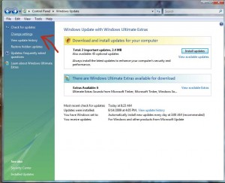](http://backroom.bostonproductions.com/wp-content/uploads/2009/09/WindowsVistaKiosk1.jpg)

Change The Default Windows Update Behavior

**Turn off Windows Defender**

Kiosk machines are not general use machines.  Windows defender scanning while people are using your kiosk is not going to add value anywhere.  The most likely result of this will be bog in processing intensive interactive exhibits.  Just turn off Windows Defender.  You can get to these options in the Control Panel -> Windows Defender -> Tools -> Options.

[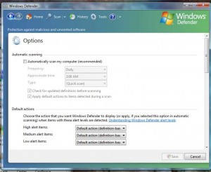](http://backroom.bostonproductions.com/wp-content/uploads/2009/09/WindowsVistaKiosk2.jpg)

You Don't Need Defender in a Kiosk

**Modify the Power Settings to Prevent Screen Turn off and Sleep**

Default power settings will turn off your monitor, hard drives, and put the machine to sleep.  We don’t want a kiosk to make itself unavailable in order to save power.  Please note that the following options change based on what Vista Service Pack you have installed.  (As of Service Pack 2) Control Panel -> Power Options -> Change when to turn off the display AND Change when the computer sleeps.

**Modify the BIOS Power Settings**

In the Bios of most computers, there is an option of what to do when AC power is lost.  By default this option usually will keep the computer off.  However, we always want the computer to turn back on!  Change the AC Power recovery settings if you can.

[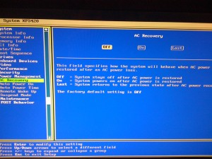](http://backroom.bostonproductions.com/wp-content/uploads/2009/09/WindowsVistaKiosk12.jpg)

AC Power Settings on a Dell

**Make the Computer Automatically Login at Startup**

In Windows Vista we use a tool called control userpasswords2 to do this.  You can access this by start-> run -> control userpasswords2

[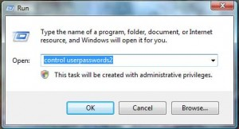](http://backroom.bostonproductions.com/wp-content/uploads/2009/09/WindowsVistaKiosk3.jpg)

Control User Passwords...2

This opens up a User Accounts dialog.  In order to login automatically under a certain account, click that account to highlight it, then uncheck the box that says “Users must enter a user name and password to use this computer”.  When you hit “Apply” you are going to be prompted for the users password.

[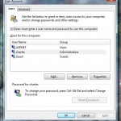](http://backroom.bostonproductions.com/wp-content/uploads/2009/09/WindowsVistaKiosk4.jpg)

Select the User you Want to Login

[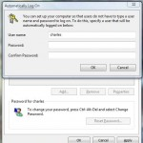](http://backroom.bostonproductions.com/wp-content/uploads/2009/09/WindowsVistaKiosk5.jpg)

Enter the User Credentials

Congratulations as when you restart, it will now login automatically as this user.

**Disable TMM Scheduled Task – Transient Multimonitor Manager**

Windows Vista by default has a scheduled task called Transient Multimonitor Manager that is on by default for all versions of Vista.  TMM is intended for laptop users that are hooking and unhooking external monitors.  In a kiosk environment we will often have very strict display settings that we never want to automatically change.  TMM may contribute to automatic changes in multiple display setups which is extremely frustrating.  Just disable this scheduled task!  You can do this by the following actions: Control Panel -> Administrative Tools -> Task Scheduler.  Inside the Task Scheduler open the “Windows” tasks and under “Mobile PC” you will see the TMM task.  End and Disable the task.

[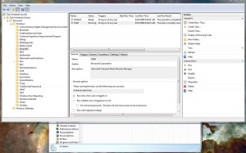](http://backroom.bostonproductions.com/wp-content/uploads/2009/09/WindowsVistaKiosk6.jpg)

You Don't Need the TMM Service

**Hide the Taskbar and Notification Popups**

Depending on how you’re interactive is setup, you’re probably going to have to change the behavior of the Windows Vista taskbar so that it stays hidden and doesn’t ever interrupt the interactive and user experience.  Right click on the taskbar -> Properties.  In the Taskbar tab, I usually Auto-hide the taskbar, uncheck “Keep the taskbar on top of other windows”.

[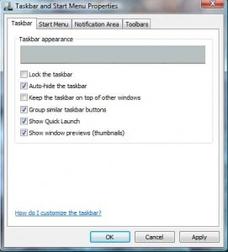](http://backroom.bostonproductions.com/wp-content/uploads/2009/09/WindowsVistaKiosk7.jpg)

Hide that Taskbar

In the Notification Area tab we need to handle how icons display information.  You know how application icons like to pop up notifications?  These will interrupt your interactive too!  Click on the “Customize” button next to Hide inactive icons.  I Hide everything. (Please Note: This is my development machine not a kiosk machine in the example.  I would never run AV software on a kiosk machine).

[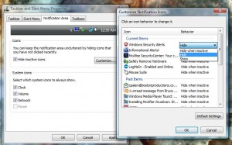](http://backroom.bostonproductions.com/wp-content/uploads/2009/09/WindowsVistaKiosk8.jpg)

Hide Taskbar Icons in Vista

**Restore Points and Auto Recovery**

This is a special category because there are a few things that you need to do in order to prevent all the automated recovery tools in Windows Vista from bringing havoc to your kiosk setup.  We usually setup our systems and expect them not to change for a year or more.  By default Windows Vista will do everything in its power to change, or revert your system configuration under certain circumstances.

**Windows Vista Will Auto Restore to the Last Known Restore Point Under the Following Common Kiosk Situation**

Whenever a Windows Vista system looses power during its startup sequence, the next time it turns on, it will automatically (unless a user specifies in thirty seconds) boot into the recovery console and start running a “System Startup Recovery”.  If for some crazy reason, the machine looses power during a System Startup Recovery, Vista will automatically restore itself to the last restore point!

[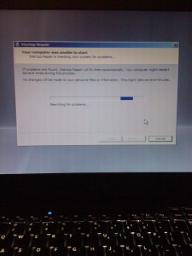](http://backroom.bostonproductions.com/wp-content/uploads/2009/09/WindowsVistaKiosk13.jpg)

Windows Vista Auto Startup Recovery

In the museum and visitor center industry, we normally use an AMX or Crestron master control system to hard power off and on museum kiosk systems each day.  In the strange event that the institution turns their master control system on and off a few times within a short period, the above normally happens to all the Vista based kiosk systems!  Kiosk systems that are self contained are vulnerable to this type of strange occurrence if the building has fluctuating power during an electrical storm as well, or if a maintenance person just decides to turn the computer on and off a few times manually.

[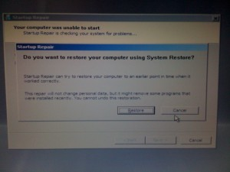](http://backroom.bostonproductions.com/wp-content/uploads/2009/09/WindowsVistaKiosk14.jpg)

Vista Is Unable to Repair my Startup. I Induced This by Forcing Power Off.

**Disable the Restore Point Scheduled Task**

By default Windows Vista creates a restore checkpoint every single day.  In a kiosk environment we don’t want this at all.  The only checkpoint we are interested in, is one that we know is configured the way we initially setup the working kiosk system.  I have had systems that start in an unexpected way, create a checkpoint of that configuration, then repeatedly roll themselves back to a bad configuration.  In order to disable the Restore Point Scheduled Task, go to Control Panel -> Administrative Tools -> Task Scheduler.  In the Task Scheduler in the Microsoft -> Windows Tasks you will see the “SystemRestore” category.  In that category you will find the SR scheduled task that should be stopped and disabled.

[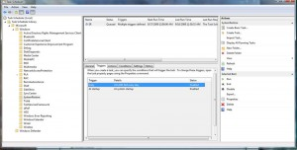](http://backroom.bostonproductions.com/wp-content/uploads/2009/09/WindowsVistaKiosk9.jpg)

Windows Vista System Restore Scheduled Task

***Create a Manual Restore Point of the Good Configuration***

Under certain circumstances, Windows Vista will without user interaction, restore your system to the previously known good configuration.  We need to control what Vista will restore to when this happens.  In order to make a manual restore point, do the following: Start Menu -> Right Click on Computer -> Properties -> Advanced System Settings -> System Protection Tab.  The “Available Disks” dialog box may take a little bit of time to populate.  You can click the “Create” button at the bottom of the System Protection tab in order to create a system restore point.

[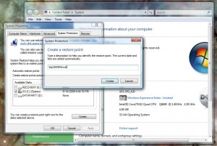](http://backroom.bostonproductions.com/wp-content/uploads/2009/09/WindowsVistaKiosk10.jpg)

Windows Vista Manual Restore Point

***Get Rid of Previous Restore Points***

Due to the auto-restore functionality inherent in Windows Vista above, you need to make sure only the manual restore point remains.  You can delete all the previous daily restore points by use the Windows Vista Disk Cleanup utility.  The Disk Cleanup utility can be accessed in the following way:  Start Menu -> All Programs -> Accessories -> System Tools -> Disk Cleanup.  Select Your System Drive when you are prompted.  On the More Options tab in Disk Cleanup you will find the option to delete System Restore and Shadow Copies.  This operation will probably freeze the computer for a little bit.

[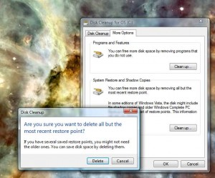](http://backroom.bostonproductions.com/wp-content/uploads/2009/09/WindowsVistaKiosk11.jpg)

Windows Vista Disk Cleanup

I hope that covers all of the automated features that need to be disabled in order to give you a rock solid kiosk system in Windows Vista.  I would be extremely interested if anyone knows how to disable the automatic restore from power loss process.