Friends of Oscar 0 Meeting – 6-9-11

Meeting was held at the EDC office. Members in attendance included Helene Fossum, Rebecca Edland, Pastor Charles Johnson, Mark Sundlov and Becky J Meidinger. Meeting was called to order at 12:00 pm.

The agenda was reviewed and a motion was made by Pastor Johnson and seconded by Helene to approve the agenda as presented and motion passed. The minutes were read and a motion was made by Helene and seconded by Pastor Johnson to approve the minutes as read. Motion passed.

The financial report was given. There was a total of $6,010.81 in the Friends checking account. This was based on information given to Becky by Jan, as she was unable to be present at the meeting. A check for $100.00 was received by the Pizza Ranch for the coupons from last year’s printing. There were a few bills to be paid, but Jan hadn’t received the invoices yet. A motion was made by Becky and seconded by Pastor Johnson to approve the financials and pay the outstanding due bills. Motion passed. Becky informed the group that she had applied to the Cooperstown Community Foundation for a $500 grant and this was approved, so these grant funds can be used to help with signage and/or marketing.

There was discussion about advertising and marketing, and it was decided that we really need to have an advertising budget and a plan for our marketing efforts. We also need to have updated brochures and information for the reunion to encourage more memberships and show what has been going on. There was a copy shared of the advertising done in the ND Living Magazine. There should be a membership brochure and then an informational brochure developed that could be put in the rest areas or for our local businesses to share with visitors. Rebecca talked about her idea for an outdoor information booth that would not have to be manned, but could be set up so visitors could readily find information about the community and the sites, something like a tourism kiosk. A possible location for this might be in the community pocket park on our main street. There was some discussion about having a table set up during the fair to encourage new memberships, and Helene said she would be willing to help with this if we did set something up. There was further discussion about having something that could readily be set up for all types of local events and would include a laminated membership application and information, possibly several pictures of Oscar Zero and the Cold War Interpretive Center and other pertinent information to showcase the sites. Mark said he has been doing a lot of advertising on the radio and will put something on the Pigskin Pics and the basketball pool printed materials.

Mark said the numbers at Oscar Zero for this year so far are very similar to last year’s numbers so they are okay with that.

Additional ideas for fundraising were discussed. There is a vintage car tour coming to Cooperstown on August 10th and Becky asked if the Friends group wanted to put on the meal for this, but if we were to do this, we would also need help from the museum group. Not sure if there would be enough interest in doing this as it is on a weekday and would be hard for people to get away to help. Becky and Rebecca will discuss this further.

An update was given on the reunion. There are going to be several jobs that will need to be done during the registration and the event. The numbers of registrations is not final yet, but we will be going forward with this even if the numbers are low. The Grand Forks CVB will be helping with some of the registration forms, some welcome banners and name tags, but we will need to man the registration table on Thursday night and Friday morning. Registration table will need to be set up no later than 1:00 pm on Thursday. Wade and Pastor Johnson said they would be able to help with this. The program for the three days was discussed and Wade will take care of the set up at the school for Saturday night. The caterer for the meal for Saturday has not been secured yet, so the committee will continue to work on that. It was discussed having tickets for the general public to purchase for the meal on Saturday night, so we need to figure out how that is going to be handled. There will need to be posters made and marketing done to promote this. The meal on Saturday night will be $20.00 per person.

With no further business to discuss, it was decided to have the next meeting on July 14th at noon at the EDC office. Meeting was adjourned.

Respectfully submitted,
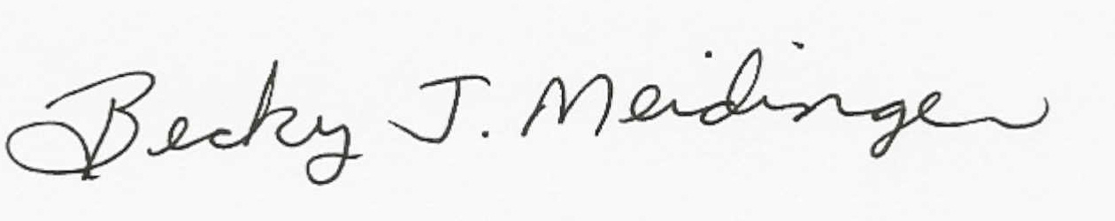
Becky J Meidinger, Secretary

