Connie,
Jan mentioned that you would be willing to help us with the website, and we are really looking forward to your input.
We really need input on the design, layout and contents of the website, and not just grammar.
An example would be the page at http://www.oscarzero.com/aboutus.htm
It might look like the following one hour:
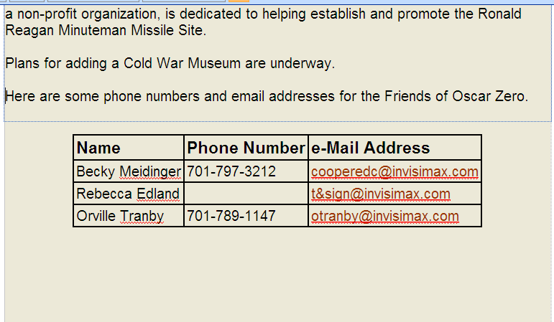
and then an hour later look like:
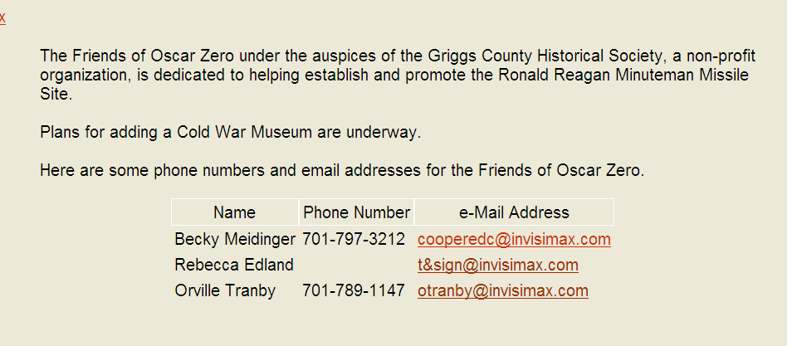
The changes between the two are in the margins, font types, font sizes, whether a font is bold or not, whether it is centered or left justified, font colors, table colors around the cells, space between table entries, etc. etc. We will be looking at changing the background colors and foreground colors to set the table apart from the rest of the document.
We would really like your input on which of the two options above is better, or whether it should be some new combination of the two options.
If you click the X on the upper left side of this page, you can see some additional changes that we are contemplating.
There are many different ways you could contribute. We could give you the password to the site and you could make the changes directly to the site. The pages are in html format.
For example, the word "Name" in the first picture above is set up as:
th.style1 {
border: 1px solid #000000;
text-align:left;
font-size:large;
font-weight:bold
}
and it is set up in the second picture as:
th.style1 {
border: 1px solid #ffffff;
text-align:center;
font-size:medium;
font-weight:lighter}
We make the changes above with an html text editor and then upload the results to get each other's comments on the new style.
We were both really hoping that we would get a lot more input from the Friends on all of these issues, but haven't received any constructive criticism yet.
It might be easier if you just browse to each page and take a critical look at them. Then just email me or Dave with any changes or suggestions on the grammar, style, contents, etc. We can then make the design changes and make sure the underlying code is not damaged.
Jan mentioned that we should "forward to you the website". The closest we could come to doing that would be to send you a copy of the html pages, but I'm not sure you want to do html text editing. Microsoft Word doesn't work very well, and Dave and I each use different special html programs for editing.
I'm leaving town for about a month, otherwise I would try to stop by and visit with you next week. I guess we'll just have to email each other until I get back.
Anyway, we look forward to hearing back on your comments and suggestions.
Ron
P.S. If you're already an experienced website developer, I sure don't want you to think I was talking down to you on website editing details.

